DESIGN AND DEVELOPMENT OF A MEDICAL TELEMETRY SYSTEM

A THESIS SUBMITTED TO
THE GRADUATE SCHOOL OF APPLIED SCIENCES
OF
NEAR EAST UNIVERSITY
by
İSMAİL ÇALIKUŞU

In Partial Fulfilment of the Requirements for
the Degree of Master of Science
in
Biomedical Engineering

NICOSIA 2012

ABSTRACT

Medical telemetry is very important because every second is very crucial for a patient’s life as the health condition of the patient is required to be sent to a health specialist as soon as possible. For example, if the heart stops, the person doesn’t survive for more than a few minutes. Medical telemetry systems are very advanced with developing technologies such as wireless and Ethernet systems. Ethernet and wireless technology play important roles together in the medical telemetry systems because of their continuous high speed and high data transmission rates. Electrocardiogram signal (ECG) and blood oxygen saturation (SpO2) signals are two of the important indicators directly related to heart-pulmonary system. Monitoring and following of ECG and SpO2 offers us a good indication of heart functionality. Therefore, it is crucial to design and develop a homemade inexpensive device for measuring the Heart Rate and SpO2. In addition to this, data is required to be sent instantly so that it can be monitored and analysed remotely by the health specialist.

In the medical telemetry system designed and developed by the author, ECG and SPO2 signals are obtained using instrumentation amplifiers with filters, and are sent with serial Ethernet board to a remote place for analysis. Signals are transmitted in text format using suitable Ethernet boards. The developed system allows a health specialist to send data easily and cheaply to any required place.

Key words: Medical Telemetry, Biotelemetry, ECG, SPO2, Ethernet.

ÖZET
Medikal telemetri sistemlerinin kullanımı hayati bir öneme sahiptir. Çünkü hastanın hayatta kalabilmesi için hastanın durumunun sağlık uzmanına mümkün olabildiğince hızlı bir şekilde yollanması gerekmektedir. Örneğin, kalbin çalışması durursa kişi birkaç dakikadan fazla hayatını devam ettiremez. Medikal telemetri sistemleri gelişen kablosuz ve Ethernet sistemleri teknolojileri ile birlikte önemli bir ilerleme kaydetmiştir. Ethernet ve kablosuz teknolojileri sürekli yüksek hız ve veri iletim hız oranlarıyla medikal telemetri sistemlerinde önemli bir işleve sahiptir. Elektrokardiyogram (EKG) ve kandaki oksijen doyumu (SPO₂) sinyalleri kalbin dolaşım sistemleri hakkında iki önemli gösterge niteliğindedir. EKG ve SPO₂’nin görüntülenmesi ve izlenmesi kalbin çalışma fonksiyonu hakkında bize önemli bilgiler sunacaktır. Bu yüzden, SPO2 ve kalbin atış hızını ölçebilen ve uzak bir yerde bulunan sağlık personeline anlık olarak gönderebilen ev tipi cihazların tasarlanması hasta açısından hayati bir önem arz etmektedir.

Yazarın gerçekleştirmiş olduğu sistemde EKG ve SPO₂ sinyalleri enstrumantasyon yükselteçleri kullanılarak tasarlanmış olup analiz için uzak istasyona gönderilmiştir. Sinyaller text (metin) formatında Ethernet portu kullanılarak iletilmiştir. Sistem sağlık personeline gerekli herhangi bir yere verinin kolayca ve ucuz bir şekilde yollama imkânı sağlamaktadır.

Anahtar Sözcükler: Medikal telemetri, biyotelemetri, EKG, SPO2, Ethernet.

LIST OF CONTENTS

ABSTRACT.....................................................................................................................ii
ÖZET...............................................................................................................................iii
CONTENTS
.iv
ACKNOWLEDGEMENTS……………………………………………………..….……vi LIST OF FIGURES………..…………………………………………………………….vi LIST OF TABLES…..…………………………………………………………………..ix ABBREVIATIONS USED……………………………………………………………...
.x
454.5. Summary 4.4.Pulse Oximeter Instrumentation 434.3. History of Pulse Oximetry 424.2.Principles of Pulse Oximetry 38CHAPTER 3, THE ECG MACHINE . 162.7 Summary 152.6.4 Intracoronary ECG 152.6.3 Endotracheal ECG 152.6.2 Intracardiac ECG 142.6.1 Esophageal ECG Leads 132.6 Other types of ECG Leads 132.5.3 ECG Chest Leads 122.5.2 ECG Augmented Limb Leads 112.5.1 ECG Limb Leads 102.5 Placement of ECG Recording Surface Electrodes 92.4 Heart Conduction System and Electrical Activity of Heart 72.3. Mechanism of Heart Working 5 2.2. Heart Structure 4 CHAPTER 1, INTRODUCTION..................................................................................1 2.1 Overview 4CHAPTER 2, THE HUMAN HEART 44.1 Overview 383.1 Overview 173.2.ECG History 183.3.ECG Instrumentation 19213.4.Biopotential Electrodes for ECG 3.4.1.Electrode Electrode Interface 213.4.2.Polarization..... 23363.4.3. Electrical Characteristics 253.4.4.Practical Electrodes for Biomedical Mesurements 273.4.4.1.Body Surface Biopotential Electrodes 27283.4.4.2.Metal Plate Electrodes 3.4.2.Electrodes for Chronic Patient's Monitoring 293.4.3.Intracavitary and Intratissue Electrodes..... 323.4.4.Microelectrodes 353.4.5.Summary CHAPTER 4, SPO2 38
CHAPTER 5, MEDICAL TELEMETRY SYSTEMS
46
5.1 Overview
46
5.2 General Description of Medical Telemetry
46
5.3 Brief History of Medical Telemetry System
47
5.4. Types of Medical Telemetry Systems
48
5.4.1 Single Channel Medical Telemetry Systems
48
76 APPENDIX A INA128 Instrumentation Amplifier block diagram REFERENCES 74726.4 Summary 646.2.2 Pulse Oximeter System 576.2.1 The ECG Measurement System 5351505.5 Summary 5.4.2 Multi Channel Medical Telemetry Systems 49CHAPTER 6, DESIGN OF A TELEMETRY SYSTEM 6.2 Medical Telemetry System 526.1 Overview 526.3 Software of Medical Telemetry System 646.2.3 Microcontroller System 61CHAPTER 7, RESULTS AND DISCUSSSION 66CHAPTER 8, CONCLUSIONS
78APPENDIX C Software of design system APPENDIX B Nellcorr Pulse Oximeter Probe Pinout for disposable 77APPENDIX D Pulse Oximeter Signal which eliminated DC effect
92

ACKNOWLEDGEMENTS

First and foremost I offer my sincerest gratitude to my supervisor, Prof. Dr. Dogan Ibrahim, who has supported me throughout my thesis with his patience and knowledge. I attribute the level of my Masters Degree to his encouragement and effort and without him this thesis, too, would not have been completed or written. One simplify could not wish for a better or friendlier supervisor. My thanks and appreciation goes to my thesis committee members. I am greatly indebted to my administrator, Ass. Prof. Dr Terin Adalı, for her relationship and guidance. I am also thankful for the contributions and comments of the teaching staff of the Department of Biomedical Engineering, especially Prof.Dr.D.İbrahim for his kind help.
I am especially grateful to Ass.Prof.Dr Uğur Fidan from Turkey for being a constant source of encouragement and helped me gain self confidence. Here also I would like to thank to my colleagues and friends at the Department of Biomedical Engineering who helped me one way the other. In addition to this, I would like to thank my school headmaster Selçuk ATAKAN and my teacher friends for their relationship and friendlier behaviour.
My final words go to my family. I want to thank my family, whose love and guidance is with me in whatever I pursue.

LIST OF FIGURES
Figure 2.1 Place of heart in the chest 4
Figure 2.2 Heart wall layers 5
Figure 2.3 Structure of the heart 7
Figure 2.4 Heart conduction system 8
Figure 2.5 The ECG wave 9
Figure 2.6 Standard ECG limb leads 10
Figure 2.7 ECG augmented limb leads 11
Figure 2.8 ECG chest leads 12
Figure 2.9 Esophageal ECG wave 13
Figure 2.10 Intracardiac ECG and electrode 14
Figure 3.1 Einthoven ECG machine 17
Figure 3.2 Modern ECG machine 18
Figure 3.3 Block Diagram of typical single channel ECG circuit 19
Figure 3.4 Instrumentation amplifier 20
Figure 3.5 Electrode-electrode interface 22
Figure 3.6 The equivailent circuit for a biopotential electrode 26
Figure 3.7 An exp. of biopotential electrode impedance as a function of frequency 26
Figure 3.8 Metal plate electrode 28
Figure 3.9 Suction type electrode for ECG 29
Figure 3.10 Recessed type electrodes 30
Figure 3.11 Examples of Different type electrodes 31
Figure 3.12 Examples of different internal electrodes 33
Figure 3.13 Microelectrodes 35
Figure 4.1 Haemoglobin and Oxygen Transportation 39
Figure 4.2 Absorption coefficient two types 40
Figure 4.3 Schematic of finger pulse oximeter idea 40
Figure 4.4 Normal detected signal in red and infrared for SPO2 41
Figure 4.5 Browse hand held Pulse Oximetry 43
Figure 4.6 Block diagram of finger tip pulse oximeter 43
Figure 4.7 Timing signals for the LED drivers such as red and infrared 44
Figure 5.1 Block diagram of medical telemetry system 46
Figure 5.2 Block Diagram of a Single Channel Telemetry System 48
Figure 5.3 FM-FM modulated radio telemetry transmitter for ECG 49
Figure 6.1 Block diagram of Medical Telemetry design system 51
Figure 6.2 Block diagram of ECG measurement system 52
Figure 6.3 ECG Measurement system circuit 53
Figure 6.4 The output signal ECG signal from INA128KP 54
Figure 6.5 Block diagram of medical telemetry system 46
Figure 2.1 Place of heart in the chest 4
Figure 2.2 Heart wall layers 5
Figure 2.3 Structure of the heart 7
Figure 2.4 Heart conduction system 8
Figure 2.5 The ECG wave 9
Figure 2.6 Standard ECG limb leads 10
Figure 2.7 ECG augmented limb leads 11
Figure 2.8 ECG chest leads 12
Figure 2.9 Esophageal ECG wave 13
Figure 2.10 Intracardiac ECG and electrode 14
Figure 3.1 Einthoven ECG machine 17
Figure 3.2 Modern ECG machine 18
Figure 3.3 Block Diagram of typical single channel ECG circuit 19
Figure 3.4 Instrumentation amplifier 20
Figure 3.5 Electrode-electrode interface 22
Figure 3.6 The equivailent circuit for a biopotential electrode 26
Figure 3.7 An ex. of biopotential electrode impedance as a function of freq 26
Figure 3.8 Metal plate electrode 28
Figure 3.9 Suction type electrode for ECG 29
Figure 3.10 Recessed type electrodes 30
Figure 3.11 Examples of Different type electrodes 31
Figure 3.12 Examples of different internal electrodes 33
Figure 3.13 Microelectrodes 35
Figure 4.1 Haemoglobin and Oxygen Transportation 39
Figure 4.2 Absorption coefficient two types 40
Figure 4.3 Schematic of finger pulse oximeter idea 40
Figure 4.4 Normal detected signal in red and infrared for SPO2 41
Figure 4.5 Browse hand held Pulse Oximetry 43
Figure 4.6 Block diagram of finger tip pulse oximeter 43
Figure 4.7 Timing signals for the LED drivers such as red and infrared 44
Figure 5.1 Block diagram of medical telemetry system 46
Figure 5.2 Block Diagram of a Single Channel Telemetry System 48
Figure 5.3 FM-FM modulated radio telemetry transmitter for ECG 49
Figure 6.1 Block diagram of Medical Telemetry design system 51
Figure 6.2 Block diagram of ECG measurement system 52
Figure 6.3 ECG Measurement system circuit 53
Figure 6.4 The output signal ECG signal from INA128KP 54
Figure 6.5 Notch filter circuit for ECG 55
Figure 6.6 Sallen Key High Pass Filter for ECG 56
Figure 6.7 Sallen Key Low Pass Filter for ECG 56
Figure 6.8 Output signal of ECG measurement system 57
Figure 6.9 Block diagram of finger tip pulse oximeter system 57
Figure 6.10 The output signal for red and infra-red light 59
Figure 6.11 Bipolar 555 Timer circuit and pulse signal in oscilloscope 60
Figure 6.12 Pulse oximeter circuit with nellcor probe connection 60
Figure 6.13 The output signal of INA110KP instrumentation amplifier circuit 61
Figure 6.14 The output signal from Pulse Oximeter system 62
Figure 6.15 Pin diagram of DSPIC30F6014A 63
Figure 6.16 Microcontroller and Serial Ethernet circuit system 64
Figure 7.1 The output signal of ECG system 68
Figure 7.2 The output signal of pulse oximeter system 69
Figure 7.3 ECG and SPO₂ signal monitoring in GLCD 70

ABBREVATIONS
LCD: Liquid Crystal Display
SPO₂: Saturation Peak of Oxygen in blood.
CMRR: Common Mode Rejection Ratio
GLCD: Graphical Liquid Crystal Display
AC: Alternative Current
DC: Direct Current
PC: Personality Computer
PCM: Pulse Code Modulation
FM: Frequency Modulation
FSK: Frequency Shift Key
GPRS: General Packet Radio Service
ARX: Mach like operating system for Acorn Computer
PDA: Personal Digital Assistant
AC: Access Point
AV: Atrioventricular
aVR: Augmented Vector Right
LED: Light Emitting Diode
RA: Right Arm
LA: Left Arm
RL: Right Leg
LL: Left Leg
aVL: Augmented Vector Left
IR: Infrared
LF: Low Frequency
HF: High Frequency
DSP: Digital Signal Processing
SL:Semilunar
aVF: Augmented Vector Foot
RAM: Read Access Memory
EMG: Electromyography
BPF: Band Pass Filter
HR: Heart Rate

LIST OF TABLES
Table 3.1 The effect of electrode properties on electrode impedance 27

CHAPTER 1

INTRODUCTION

Medical Telemetry is a way of transmitting data electronically from one point to another. In a typical medical telemetry application, equipment record electronic data related to a patient and then send this data to a desired central area where it can be displayed on LCD or TV screens for qualified medical staff to monitor so that any urgent medical problems can be attended to as soon as possible.

The doctors who admit a person to the hospital decide what level of care he or she needs. Doctors send some patients to telemetry units when they are concerned about the long term health problems of these people. For example, elderly patients who cannot go to hospitals easily are usually sent to medical telemetry units where their health problems can be monitored over long periods of times. Some medical telemetry equipments are placed at patient’s home so that the health of the patient can be monitored remotely.

The most important medical parameters measured at telemetry units are the electrocardiogram (or ECG), and level of the saturated oxygen in patient’s blood. These two parameters tell a lot to a doctor about a patient’s health problems.

This thesis is about the design and development of a microcontroller based medical telemetry device. The design is based using suitable sensors and electrodes to collect data about a patient’s electrocardiogram and level of saturated oxygen in their bloods. The collected information is sent over a serial Ethernet link to a remote location where the data can be analysed by qualified doctors and health staff.

This thesis consists of 7 Chapters. Chapter 1 is the introduction.

Chapter 2 is related to the human heart. This Chapter described the basic operating principles of the human heart. Every year, may people are admitted to hospitals because of heart related problems, e.g. heart disease or heart attack. For this reason, it is important to have a good understanding of the human heart. The Chapter describes the typical electrical signals present on a human heart.

Chapter 3 is about the electrocardiogram machine (ECG). The ECG machine detects the signals emitted by the heart using suitable electrodes connected to the chest of a patient. By analysing the ECG waveforms, doctors can tell a lot about the state of a patient’s heart. The Chapter gives a brief introduction to the history of the ECG machine and the operation of the machine is described together with the various methods that the electrodes can be connected to the chest.

Chapter 4 is related to pulse oximetry. Pulse oximetry is a general term used for the non-invasive measurement of the level of saturated oxygen in the blood. The Chapter describes the basic principles of the pulse oximetry and explain the importance of knowing the oxygen level in the blood.

Chapter 5 is about medical telemetry in general. The Chapter explains why medical telemetry is important for the treatment of patients. In addition, the electronic parts of various medical telemetry systems are given in detail. In general. The ECG and the level of saturated oxygen are measured in medical telemetry systems. The way these signals are measured and used in medical telemetry systems is described in detail in the Chapter.

Chapter 6 is about the medical telemetry system designed and developed by the author. The system is based on using a microcontroller as the main processing unit. It is described in the Chapter how the various system parts are put together, how the ECG and the saturated oxygen levels are measured, and how the collected data is sent to a remote location using an Ethernet based communication medium.

Chapter 7 gives the results of the tests carried out by the author. In addition, the benefits of the designed system are given in this Chapter.

Finally, the conclusions are given in Chapter 8 of the thesis.
  - Literature Search

The design of a medical telemetry system is not new. Many firms specialised in the design of medical equipment has designed medical telemetry systems. This section describes the features of some of the medical telemetry systems available in the market and discusses why the system developed by the author has advantages compared to these systems.

Guler & Fidan [1] describe the design of a medical telemetry system based on using a Radio Frequency (RF) data module to transmit the data. The collected data is converted into digital format and sent to a remote location using Pulse Code Modulation (PCM) techniques with a 9.6 Kps transmission speed. At the receiving end the received signal is converted into analog form and displayed on a PC using the Sonic Foundry Sound programme. One disadvantage of this system compared to the system designed by the author is that the communication is established using radio waves. In general radio waves have a limited coverage and are also prone to noise and attenuation. The system designed by the author uses the Ethernet protocols and the range is very long as anyone with a suitable internet link can access the system from anywhere in the world.

Di & Liu [2] describe the design of a medical telemetry system using the MSP430F149 microcontroller. The design in this paper is mainly based on a reflectance pulse oximeter and the telemetry side is not discussed in detail.

Lee [3] reports a medical telemetry system based on using Frequency Shift Keying (FSK) modulation techniques with radio waves. As with the system designed by Di & Liu, this system suffers from the same problems of range and noise.

Boskovic & Despotovic [4] describe the design of a medical telemetry system to transmit ECG signals via GPRS. Although this is an attractive concept, only the ECG data is transmitted. In addition, the system is costly compared to the system designed by the author.

Hong et al [5] describe a medical telemetry system where the communication is based on using a PDA phone. The design reported in their paper is specialised as it uses the XigBee communication medium with a limited coverage. Such a system would be acceptable in closed buildings, such as in a hospital or in a health clinic.

A medical telemetry system based on using the Bluetooth communication technology is described by Villegas et al [6]. The problem with Bluetooth based systems is that the coverage is rather limited and in general it is not possible to transmit over several hundred meters. The use of such a system would be suitable in small hospitals or health clinics.

A quick search of the internet reveals that most of the existing medical telemetry systems are either too expensive, or their ranges are rather limited. The system designed by the author offers the following advantages:

- Low-cost
- Portable (microcontroller and battery based)
- Internet based
- Adaptable to mobiles phones, IPADS and to other devices using the internet

CHAPTER 2
THE HUMAN HEART
2.1. Overview
Heart is a vital organ in the entire body with four chambers and it generates like a pump. Heart pumping blood activity is needed to continue our life. Heart electrical activity is measured with ECG electrodes which are connected to an ECG machine to monitor heart electrical activities. This chapter is about the working principles of the human heart.

2.2. Heart Structure
Heart is the one of the most important organs in the body that acts like a pump. It is really nothing more than a pump, which pumps blood through the body, beating from 60 to 120 per minute continuously in our life.
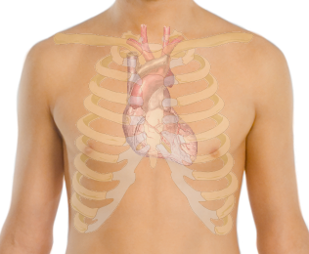
Figure 2.1.Place of heart in the chest.
The heart, the central organ of the cardiovascular system is located between the lungs in the middle chest and protected by the pericardium. The muscular walls of heart consist of three major layers. The bulk of the walls is made up of a layer of cardiac muscle and is called myocardium. Myocardium is the thick layer of cardiac muscle which is responsible for the contraction and relaxation of the ventricles and atria. The muscle is enclosed on the outside by the epicardium and on the inside by the endocardium. Endocardium is a smooth membrane of endothelial cells that lines not only chambers of the heart, but the valves as well. The heart is also covered completely by a protective sac called the pericardium. The pericardium is an extremely tough membrane that acts as protection for the heart and is not directly connected to the walls of the heart [7].
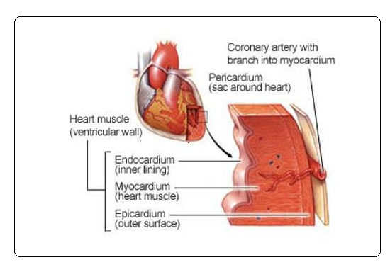
Figure 2.2.Heart wall layers.
2.3. Heart Working Mechanism
The heart (Figure 2.3) is the important key organ in the circulatory system which consists of a network of blood vessels, such as arteries, veins and capillaries. The heart pumps the blood which carries all the vital materials which help our bodies function and removes the waste product. If the pumping action of the heart is disrupted, the body’s organs begin to fail very quickly. For this reason, life itself is dependent on the efficient operation of the heart.
The heart has four valves: The tricuspid valve which is located between the right atrium and right ventricle, the pulmonary or pulmonic valve, between the right ventricle and the pulmonary artery, the mitral valve, between the left ventricle and the aorta. Each valve has a set of flaps (also called leaflets or cups). The mitral valve has two flaps; the others have three. Under normal situations, the valves permit blood to flow in only one direction. Blood flow occurs only when there’s a difference in pressure across the valves that cause them the open.
Blood returning to the heart from the body (venous blood that has already had oxygen taken from it) enters the right atrium. Blood flows and is pumped from the right atrium across the open tricuspid valve into the right ventricle.
As the right ventricle starts to contract the tricuspid valve closes (blood can only be pumped forward) the pulmonary valve opens and blood pumped into the pulmonary arteries. These arteries carry blood to the lungs to be oxygenated.
Oxygenated blood is returned to the heart by pulmonary veins. This oxygenated blood enters the left atrium. Blood from the left atrium flows across an open mitral valve to enter the left ventricle. As the left ventricle starts to contract the mitral valve closes and the aortic valve opens as blood is pumped across it into the aorta. The aorta and arteries that branch from it carry blood to the entire body. The left ventricle is the largest and most forcefully contracting chamber of the heart. It must pump oxygen rich blood to the whole body.
The heartbeat cycle consist of two components such as diastole and systole. Diastole occurs when the heart is relaxed and not contracting. During diastole blood fills each of atria and begins filling the ventricles. On the other hand, Systole occurs when electrical impulse travelling down specialized conducting fibbers trigger the heart to contract. The left and right atria contract at nearly the same time pumping remaining blood into the left and right ventricle. Systole continues as the right and the left ventricle contract, pumping blood to the lungs and body, several tenths of a second after the right and left atria have contracted. Systole and diastole continuously alternate as long as the heart continues the beat.
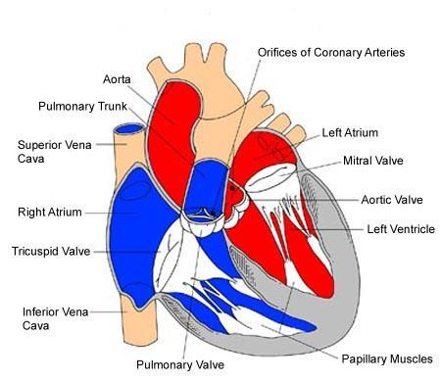

Figure 2.3.Structure of the heart [8].
2.4. Heart Conduction System and Electrical Activities of the Heart.
Heart conduction system is the process that causes the heart muscles to expand and contract rhythmically. The heart has a natural pacemaker that regulates the rhythm of heart or rate of heart. The heart rate of contraction is controlled by the sinuatrial node (SA node), often called pacemaker, is located in the upper wall of the right atrium, which is made up of specialized myocardial cells called nodal cells.
Action potentials originate in the sinuatrial node and travel across the wall of atrium from the sinuatrial node to the atrioventricular (AV) node. Action potentials pass slowly through the AV node to give the atria time to contract. Then they pass rapidly along the atrioventricular bundle, which extends from the atrioventricular node through the fibrous skeleton into the intraventricular septum. The atrioventricular bundle divides into right and left bundle branches, and action potentials descend rapidly to the apex of each ventricle along the bundle branches. Then, action potentials are carried by purkinje fibbers (or conduction pathways) from the bundle branches to the ventricular walls. The rapid conduction from the atrioventricular bundle to the ends of the purkinje fibbers allows the ventricular muscle cells to contract in unison, providing a strong contraction. The normal delay between the contraction of the atria and of the ventricles is 0.12 to 0.20 seconds. This delay is perfectly timed to account for the physical passage of blood from the atrium to the ventricle. Intervals shorter or longer than this range indicate possible problems.
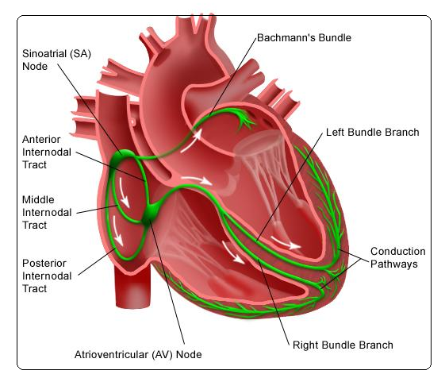
Figure 2.4.Heart conduction system.
The Electrocardiogram or ECG (Figure 2.5) records the electrical activity that results when the heart muscle cells in the atria and ventricles contract. Atrial contractions (both right and left) show up as the P wave. Ventricular contraction (both right and left) also show as a series of three waves, Q-R-S, known as the QRS complex. The third and last common wave in an ECG is the T wave. This reflects the electrical activity produced when the ventricles are recharging for the next contraction (repolarising). Interestingly, the letters P, Q, R, S and T are not abbreviations for any actual words but were chosen many years ago for their position in the middle of alphabet. The electrical activity results in P, QRS, and T waves that have a myriad of sizes and shapes. When viewed from multiple anatomic-electrical perspectives (that is, leads), these waves can show a wide range abnormalities of both the electrical conduction system and the muscle tissue of the heart’s four pumping chambers[9].
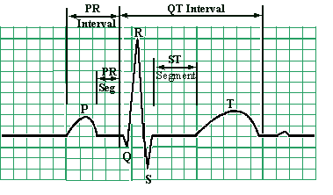
Figure 2.5.The ECG wave.
2.5. Placement of ECG Recording Surface Electrodes
The ECG is recorded by placing an array of electrodes at specific locations on the human body surfaces. Generally, electrodes are located on each arm, leg and six electrodes are located on the chest and these electrode leads are connected to a device that measures potential differences between selected electrodes to generate the characteristic ECG wave. The limb leads are sometimes called as bipolar leads because every lead uses a single pair of positive and negative electrodes. On the other hand, the augmented leads and chest leads are unipolar leads because they have a single positive electrode with the other electrodes coupled together electrically to serve as a common negative electrode.
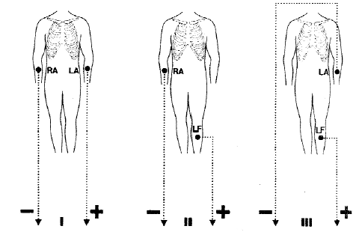
Figure 2.6.Standard ECG limb leads.
2.5.1. ECG limb leads
ECG limb leads are shown in Figure 2.6. Lead I has the positive electrode on the left arm and the negative electrode on the right arm, therefore measuring the potential difference across the chest between the two arms. In this and the other two limb leads, an electrode is placed on the right leg is used as a reference electrode for recording purposes. Lead II and lead III are not more different than Lead I. Lead II has the positive electrode which is placed on the left leg and the negative electrode which is placed on the left arm. Lead III has the positive electrode o the left leg and the negative electrode on the left arm. These three bipolar limb leads roughly form on equilateral triangle with the heart at the center tat is called Einthoven triangle is honour of Willem Einthoven who invented the electrocardiogram in 1901. Whether the limbs leads are attached to the end of the limb (wrists or ankles) or at the origin of the limbs (shoulder and upper thigh) makes virtually no difference in the recording since the limb can be viewed as a wire conductor originating from a point on the trunk of the body. The electrode located in the right leg is used as a ground.
2.5.2. ECG Augmented Limb Leads
ECG augmented limb leads are three unipolar leads and each of lead has a single positive electrode that is referenced against a combination of the other limb electrodes. Leads aVR, aVL and aVF are augmented limb leads (Figure 2.7). Lead aVR or “augmented vector right” has the positive electrode on the right arm. The negative electrode is a combination of the left arm electrode and the left leg electrode, which augments the signal strength of the positive electrode on the right arm.
The second augment lead is aVL or “augmented vector left” has the positive electrode placed on the left arm. The negative electrode is a combination of the right arm electrode and the left leg electrode, which augments the signal strength of the positive electrode on the left arm.
The third or the last augmented lead is aVF or “augmented vector foot” has the positive electrode on the left leg. The negative electrode is a combination of the right arm electrode and the left arm electrode, which augments the signal of positive electrode on the left leg [10].

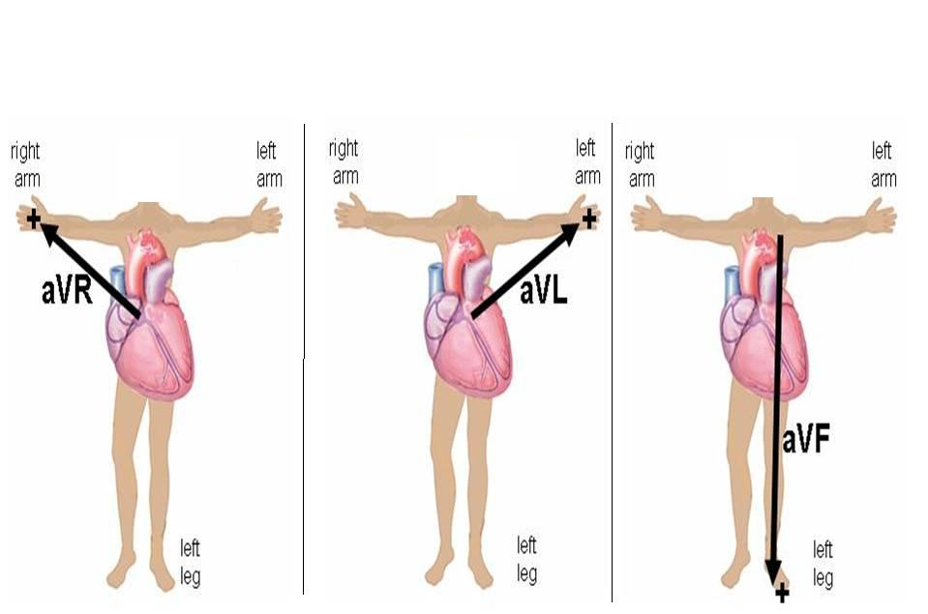
Figure 2.7.ECG augmented limb leads.

2.5.3. ECG Chest Leads
The precordial leads V1, V2, V3, V4, V5 and V6 are placed directly on the chest. Because of their close proximity to the heart, they do not require augmentation and these leads are considered to be unipolar. The precordial leads view the heart’s electrical activity in the so called horizontal plane. Leads V1, V2 and V3 are referred to as the right precordial leads and V4, V5 and V6 are referred to as the left precordial leads.
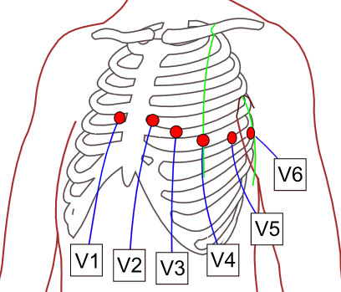
The QRS complex should be negative in lead V1 and positive in lead V6. The QRS complex should show a gradual transition from negative to positive between leads V2 and V4. The equiphasic lead is referred t as transition lead. When the transition occurs earlier than lead V3, it is referred to as a late transition. There should also be a gradual increase in the amplitude of the R wave between lead V1 and V4. This is known as R wave progression. Poor R wave progression is a nonspecific finding. It can be caused by conduction abnormalities, myocardial infarction, cardiomyopathy, and other pathological conditions.

Figure 2.8.ECG chest leads.
2.6. Other types of ECG leads.
The electric potentials of the heart can be measured not only from a surface ECG but also from body cavities adjacent to the heart itself.
2.6.1. Esophageal ECG
The concept of esophageal ECG (Figure 2.9) is not new; some researchers have demonstrated the usefulness of this approach in the diagnosis of complicated arrhythmias. The esophageal electrodes are incorporated into an esophageal stethoscope and are welded to convential ECG wires. A prominent P wave is usually displayed in the presence of atrial depolarization, and its relation to the ventricular electrical activity can be examined. To observe a bipolar esophageal ECG, the electrodes are connected to the right and left are terminals and lead I is selected on the monitor. Several investigators have described devices that allow both ECG recording from the esophagus and pacing of the heart using the same device. Esophageal electrodes have been found particularly useful in patients with emphysema or in critically ill patients in whom satisfactory surface ECG cannot be obtained.
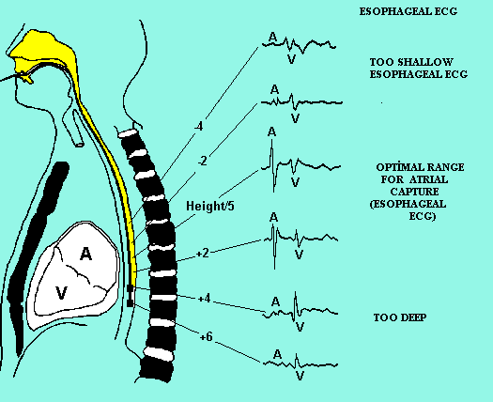
Figure 2.9.Esophageal ECG wave.

2.6.2. Intracardiac ECG
For many years, long saline-filled central venous catheters have been used to record Intracardiac ECG. More recently, Chattarjee, described the use of a modified balloon-tipped flotation catheter for recording intracavitary ECG. The multipurpose pulmonary artery catheter that is currently available has all the features of a standard pulmonary artery catheter. In addition, three atrial and two ventricular electrodes have been incorporated into the catheter. These electrodes permit recording of intracavitary ECG and the establishment of atrial or AV pacing. The diagnostic capabilities with this catheter are great because atrial, ventricular, or AV nodal arryhmias and conduction blocks can be demonstrated. The large voltages obtained from the intracardiac electrodes are relatively insensitive to electrocautery interference, thus making them useful for intraaortic balloon pump triggering. Other pulmonary artery catheters have ventricular and atrial ports that allow passage of pacing wires. These catheters can also be used for diagnostic purposes, as well as for therapeutic interventions (pacing) [11].
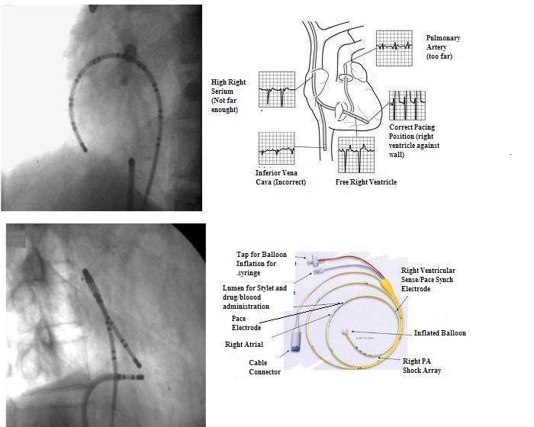
Figure 2.10.Intracardiac ECG and electrode.
2.6.3. Endotracheal ECG
The endotracheal ECG allows monitoring of the ECG when it is impractical or impossible to monitor the surface ECG. The endotracheal ECG consists of a standard endotracheal tube in which two electrodes have been embedded with nanotechnology. This device may be most useful for the diagnosis of atrial arrhythmias.
2.6.4. Intracoronary ECG
The clinical use, during angioplasty, of a coronary guide wire for the recording of intracoronary ECG was first reported during 1985. The major advantage was perceived to be greater defection of acute ischemia then with surface ECG [12].
2.7. Summary
Heart is the chambered muscular organ in vertebrates that pumps blood received from the veins in to the arteries, thereby maintaining the flow of blood through the entire circulatory system. The four valves are located in the heart; the two atrioventricular valves, which are between the atria and the ventricles, are called as mitral valve and tricuspid valves. The two other valves are semilunar (SL) valves, which are in the arteries leaving the heart, are the aortic valve and the pulmonary valve.
Heart conduction system is due to electrical impulses from heart muscles or SA node that causes the heart to beat. This electrical activity occurring in the ventricles and atrials is taken with electrodes to transmission to a machine called an ECG machine and this signal is named as Electrocardiogram, or ECG. ECG signal can be taken from the surface of body with surface electrodes, but it can also be taken from esophageal, intercoronary, intercardiac and endotracheal region of the human body with special electrodes.

CHAPTER 3
THE ECG MACHINE
3.1. Overview
Developments in the medical technologies in the past have contributed to significant improvements in patients’ care. Partly because of the technological advances, within the last 20 years the life expectancy has shifted from about 72 years to 80 years, and still increases. At the same time, the costs of health care have increased due to novel more expensive medical treatment. The challenges for engineers are to develop new or improve the methods of preventive care and decrease the costs of instrumentation as well as of personnel and maintenance. Especially Microsystems technologies offer numerous ways to generate miniaturized medical systems, since material costs and reliability can be superior to other technologies. Furthermore, miniaturizing such systems increases the patient comfort considerably.

Cardiovascular diseases are the main cause of death within the population in the age of 44 - 64 years, and the second most frequent cause of death of people between 24 and 44 years. In Turkey about 500,000 people suffer from a heart attack annually. An early recognition of attack symptoms and warning of the patient or doctor would enable preventive actions to avoid the attack and thus reduce the risk of irreparable damage to organs, or even death. Monitoring risk groups, such as people who recently were subject to a bypass surgery or pacemaker implantation, has proven to effectively decrease the number of heart attacks. Long term recording of ECG (electrocardiogram) is a standard procedure in current cardiac medicine, but the devices are capable of monitoring the heart function for a time period of only a few days, whereas much longer recording times are of clinical interest [13]. This chapter describes the basic principles of the ECG machine.

3.2. ECG History
The development of the ECG began with the discovery of the electronic potential of living tissue. This electromotive effect was first investigated by Aloysius Luigi in 1787. Through his experiments, he demonstrated that living tissues, particularly muscles, are capable of generating electricity. Afterwards, other scientists studied this effect in electronic potential. The variation of the electronic potential of the beating heart was observed as early as 1856, but it was not until Willem Einthoven invented the string galvanometer that a practical, functioning ECG machine could be made.
The string galvanometer was a device composed of a coarse string that was suspended in a magnetic field. When the force of the heart current was applied to this device, the string moved, and these deflections were then recorded on photographic paper. The first ECG machine was introduced by Einthoven in 1903 (Figure 3.1). It proved to be a popular device, and large-scale manufacturing soon began soon in various European countries. Early manufacturers include Edelman and Sons of Munich and the Cambridge Scientific Instrument Company. The ECG was brought to the United States in 1909 and manufactured by the Hindle Instrument Company.
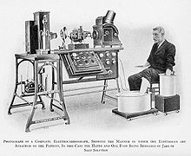
Figure 3.1.Einthoven ECG machine

Improvements to the original ECG machine design began soon after its introduction. One important innovation was reducing the size of the electromagnet. This allowed the machine to be portable. Another improvement was the development of electrodes that could be attached directly to the skin. The original electrodes required the patient to submerge the arms and legs into glass electrode jars containing large volumes of a sodium chloride solution. Additional improvements included the incorporation of amplifiers, which improved the electronic signal, and direct writing instruments, which made the ECG data immediately available. The modern ECG machine (Figure 3.2) is similar to these early models, but microelectronics and computer interfaces have been incorporated, making them more useful and powerful. While these newer machines are more convenient to use, they are not more accurate than the original ECG built by Einthoven [14].
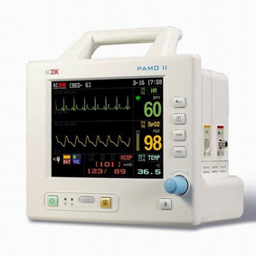
Figure 3.2.Modern ECG Machine

3.3. ECG Instrumentation.
Figure 3.3 shows the block diagram of a typical single-channel electrocardiograph. In that chain it is apparent that all filtering is done in the analog domain, while the microprocessor, micro controller, or digital signal processing (DSP) is used principally for communication and other downstream purposes. Thus the powerful computational properties of the digital core are not readily available to deal with the signal in its essentially raw state. In addition, sophisticated analog filters can be costly to the overall design due to their inflexibility- and the space, cost, and power they require.
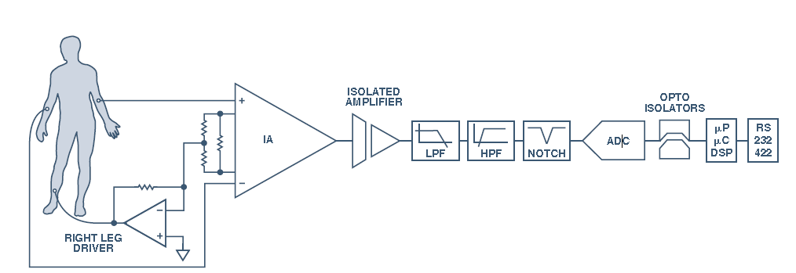
Figure 3.3.Block diagram of typical single channel ECG circuit.

Electrical activity of the heart is taken from human with electrodes, which are fixed on specific places on human body. There are many different electrodes types commercially available. They should have an adhesive area to fix them properly to the skin, clip-on wires, and a conductive gel, for stable low-noise recording. Active electrodes can also be used to improve the resolution of the recording.

Single channel ECG is generally uses three electrodes (three lead configuration) that may be placed at locations suited to the application. Three pairs of the electrodes are differential voltage inputs and one serves as a reference. This reference electrode and its associated circuit offer a large reduction of common mode voltage magnitude by actively reducing the voltage difference between patient and the ECG amplifier common by means of the so-called driven right-leg circuit design. This connection is electrically safe for the patient, which is shown in the Figure 3.3.

Amplitude of detected signal is very low, usually between 0.5 mV to 4mV, so the signal is very liable to noise influence. Instrumentation amplifier used for bioelectric signal amplifying because of its characteristics: high input impedance, high common mode rejection ratio (CMRR) and changeable gain. The high CMRR ensures that any potential on the patient's body that is common to both inputs of the differential amplifier is not amplified by the electrocardiograph.

Gain (G) is adjustable in the range 900-6800 by next equation;
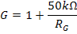
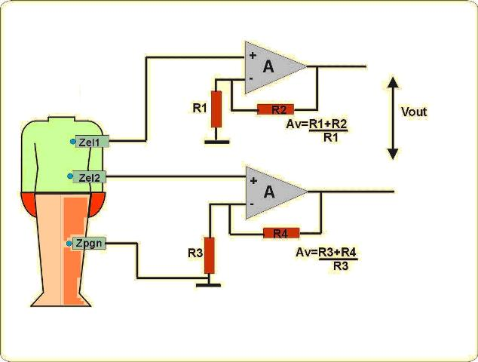

Figure 3.4.Instrumentation amplifier.
.
ECG signal is liable to following types of noise; baseline wander- low frequency (LF) noise, which arises from respiration and other physiology actions, power line noise- high frequency (HF) noise of 50 Hz/60 Hz and muscle noise- arises from action of other muscles in human body.

Baseline wander noise is eliminated by HP filter. Cutoff frequency of the low pass filter is equal to the lowest frequency of the slowest heart rate (about 40 bpm). It is about 0.67 Hz, so the chosen cutoff frequency is 0.5Hz.

3.4 Biopotential electrodes for ECG

Many important human physiological signals are electrical. An electrical connection is necessary to connect the patient to the device. One of the most common biomedical sensors is basically an electrode to measure and record potentials and currents in the body. This seems to be a very simple function, but in fact an electrode recording biopotential is actually a transducer, converting ionic currents in the body into electronic currents in the electrode. This transduction function greatly complicates electrode design. To understand how such electrodes work, we first must discuss some of the basic properties of an electrode-electrolyte interface.

3.4.1. Electrode-Electrolyte interface

The electrode-electrolyte interface is illustrated Figure 3.5. The electrode only has one type of charge carrier (electron), whereas the electrolyte has two types of charge carriers (cation and anion). The direction of current flow is noted in the figure. For charge to cross the interface, something must happen at the interface since there are no free electrons in the electrolyte and there are no cations or anions in the electrode.
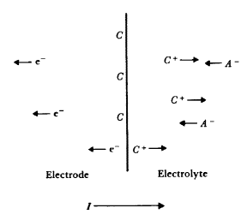
Figure 3.5.Electrode-electrolyte interface.

At the interface, charge is exchanged through chemical reactions, which can be
generally represented as:

Where n is the valence of C and m is the valence of A. Note this equation assumes that the electrode contains some atoms of the same material as the cation and that this material in the electrode at the interface can become oxidized to from a cation and one or more free electrons. Similarly, an anion coming to the electrode-electrolyte interface can be oxidized to a neutral atom, giving off one or more free electrons to the electrode.

To better understand this interaction, consider what happens when we place a piece of metal into a solution containing ions of that metal. These ions are cations, and the solution must have an equal number of anions to insure electrical neutrality of the solution. Initially the cation reaction above goes predominately to the left or right depending on the concentration of cations in solution and the equilibrium conditions for that particular reaction. The local concentration of cations in the solution at the interface changes, which affects the anion concentration as well. The net result is that charge neutrality is not maintained, and the electrolyte surrounding the metal is at a different electric potential from the rest of the solution. This is true even when no current flows across the interface.

A potential difference knows as the half-cell potential is determined by the metal involved, the concentration of its ions in solution, and the temperature. The standard half cell potential, E0, is the potential for 1M concentration solution at 25 °C when no current flows across the interface. This potential can’t be measured in the lab since two electrodes are needed to make this measurement (i.e., induce a current). To avoid this problem, electrochemists have adopted the convention that the standard half cell potential is the potential difference between a particular electrode in 1M solution to a hydrogen electrode in 1M solution. The hydrogen electrode is based on the reaction

where H₂ gas bubbled over a platinum electrode is the source of hydrogen molecules.

3.4.2. Polarization

In normal operation, the potential difference from the standard half-cell potential (i.e., half-cell potential) is determined primarily by temperature and ionic activity of the electrolyte. Ionic activity can be defined as the availability of an ionic species to enter into reaction. This process is often characterized by the reaction rate k.

The reaction rate for a process overcoming an energy barrier ∆G is

Where R is the natural gas constant and T is temperature in °K. For an electrode electrolyte interface, the energy barrier describes ionic dissociation across the interface. The electrical energy associated with this energy barrier is simply the product of free charge and the electrical potential (i.e., half-cell potential). Therefore, the energy barrier DG is related to the potential as

where n is the valence of the relevant ion, E is the potential change across the interface, and F is the Faraday constant. Using these two equations, the reaction rate related to the electrical potential difference across the interface (i.e., half-cell potential)

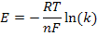

This is the famous Nernst equation of electrochemistry.

The Nernst equation can help analyze the electrode-electrolyte interaction. Consider biopotential electrode system described by the general oxidation-reduction reaction

Where n electrons are transferred. The reaction rate for this reaction is simply related to
the ratio of the activities of the products to the activities of the reactants, leading to the
general equation for the potential across the interface:

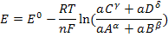

where the a’s are the appropriate activities. Similar expressions can be found fob electrolyte-electrolyte interfaces.

When a circuit is constructed which allows current to flow across an electrode electrolyte interface, the observed half-cell potential is often altered. The difference between the observed half-cell potential for a particular circuit and the standard half cell potential is known as the overpotential. Three basic mechanisms contribute to the overpotential: ohmic, concentration, and activation.

The ohmic overpotential is the voltage drop across the electrolyte itself due to the finite resistivity of the solution. These ohmic losses need not be linear with current - this is especially true in low concentration electrolytes. Overall, this is usually not a big voltage in high concentration solutions.

The concentration overpotential results from changes in ionic concentration near the electrode-electrolyte interface when current flows. With excess charge due to a finite current, oxidation-reduction reaction rates at the interface change, altering the equilibrium concentration of ions - this changes the half-cell potential.

Charge transfer in the oxidation-reduction reaction at the interface is not entirely reversible. For metal ions to be oxidized, they must overcome an energy barrier. If the direction of current flow is one way, then either oxidation or reduction dominates, and the height of the barrier changes. This energy difference produces a voltage between the electrode and the electrolyte, known as the activation overpotential.

These three polarization mechanisms add, yielding the overpotential of an electrode:

where Vr is the ohmic over potential, Vc is the concentration over potential, and Va is the activation over potential. Note that over potentials impede current flow across the interface.
3.4.3 Electrical Characteristics
The electric characteristics of biopotential electrodes are generally nonlinear and a function of the current density at their surface. Thus, having the devices represented by linear models requires that they be operated at low potentials and currents. Under these idealized conditions, electrodes can be represented by an equivalent circuit of the form shown in Figure 3.6. In this circuit Rd and Cd are components that represent the impedance associated with the electrode–electrolyte interface and polarization at this interface. Rs is the series resistance associated with interfacial effects and the resistance of the electrode materials themselves.

The battery Ehc represents the half-cell potential described above. It is seen that the impedance of this electrode will be frequency dependent, as illustrated in Figure 3.6. At low frequencies the impedance is dominated by the series combination of Rs and Rd, whereas at higher frequencies Cd bypasses the effect of Rd so that the impedance is now close to Rs. Thus, by measuring the impedance of an electrode at high and low frequencies, it is possible to determine the component values for the equivalent circuit for that electrode.
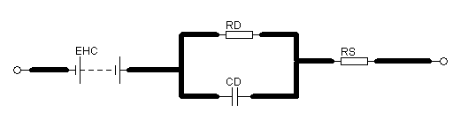
Figure 3.6.The equivalent circuit for a biopotential electrode.
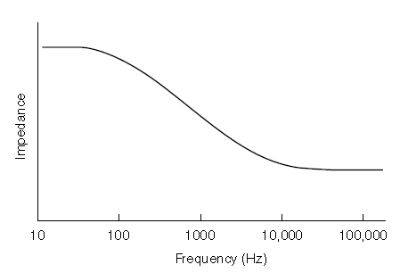
Figure 3.7.An example of biopotential electrode impedance as a function of frequency.

Table 3.1.The effect of electrode properties on electrode impedance
Property | Change in Property | Changes in electrode impedance
Surface area | ↑ | ↓
Polarization | ↑ | ↑ At low frequency
Surface Roughness | ↑ | ↓
Radius of curvature | ↑ | ↓
Surface Contamination | ↑ | ↑
↑- Increase in Quantity ↓-Decrease in property.

The electrical characteristics of electrodes are affected by many physical properties of these electrodes. Table 3.1 lists some of the more common physical properties of electrodes and qualitatively indicates how these can affect electrode impedance.

3.4.4. Practical Electrodes for Biomedical Measurements

Many different forms of electrodes have been developed for different types of biomedical measurements. To describe each of these would go beyond the constraints of this article, but some of the more commonly used electrodes are presented in this section. The reader is referred to the monograph by Geddes for more details and a wider selection of practical electrodes.

3.4.4.1. Body-Surface Biopotential Electrodes

This category includes electrodes that can be placed on the body surface for recording bioelectric signals. The integrity of the skin is not compromised when these electrodes are applied, and they can be used for short-term diagnostic recording such as taking a clinical electrocardiogram or long-term chronic recording such as occurs in cardiac monitoring.
3.4.4.1.1. Metal Plate Electrodes

The basic metal plate electrode consists of a metallic conductor in contact with the skin with a thin layer of an electrolyte gel between the metal and the skin to establish this contact. Examples of metal plate electrodes are seen in Figure 3.8. Metals commonly used for this type of electrode include German silver (a nickel–silver alloy), silver, gold, and platinum.
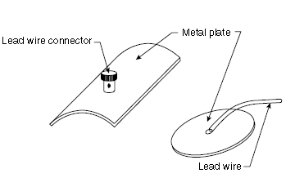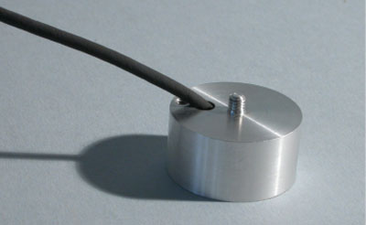
- (b) (c)

Figure 3.8.Metal plate electrode a) schematic b) picture c) disposable metal type.

Sometimes these electrodes are made of a foil of the metal so as to be flexible, and sometimes they are produced in the form of a suction electrode (Figure 3.9) to make it easier to attach the electrode to the skin to make a measurement and then move it to another point to repeat the measurement. These types of electrodes are used primarily for diagnostic recordings of biopotentials such as the electrocardiogram or the electroencephalogram.
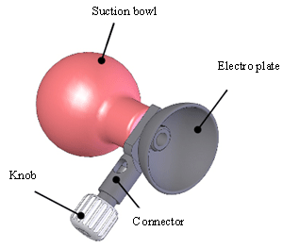
Figure 3.9.Suction type electrode for ECG.

3.4.4.2 Electrodes for Chronic Patient Monitoring

Long-term monitoring of biopotentials such as the electrocardiogram as performed by cardiac monitors places special constraints on the electrodes used to pick up the signals. These electrodes must have a stable interface between them and the body, and frequently nonpolarizable electrodes are, therefore, the best for this application. Mechanical stability of the interface between the electrode and the skin can help to reduce motion artifact, and so there are various approaches to reduce interfacial motion between the electrode and the coupling electrolyte or the skin. Figure 3.10 is an example of one approach to reduce motion artifact by recessing the electrode in a cup of electrolytic fluid or gel. The cup is then securely fastened to the skin surface using a double-sided adhesive ring. Movement of the skin with respect to the electrode may affect the electrolyte near the skin–electrolyte interface, but the electrode–electrolyte interface can be several millimeters away from this location, since it is recessed in the cup. The fluid movement is unlikely to affect the recessed electrode–electrolyte interface as compared to what would happen if the electrode was separated from the skin by just a thin layer of electrolyte.
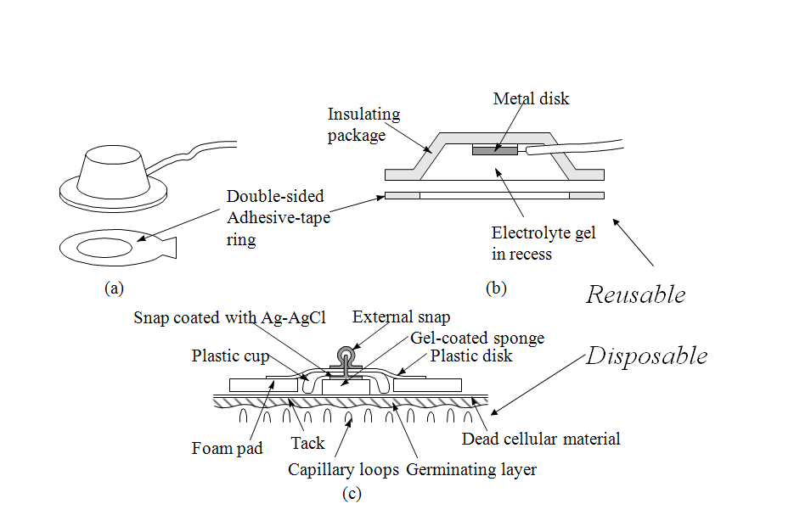
Figure 3.10.Recessed electrode types.

The advantages of the recessed electrode can be realized in a simpler design that lends itself to mass production through automation. This results in low per-unit cost so that these electrodes can be considered disposable. Figure 3.11.a illustrates such an electrode in cross section. The electrolyte layer now consists of an open-celled sponge saturated with a thickened (high-viscosity) electrolytic solution. The sponge serves the same function as the recess in the cup electrodes and is coupled directly to a silver–silver chloride electrode. Frequently, the electrode itself is attached to a clothing snap through an insulating-adhesive disk that holds the structure against the skin. This snap serves as the point of connection to a lead wire. Many commercial versions of these electrodes in various sizes are available, including electrodes with a silver–silver chloride interface or ones that use metallic silver as the electrode material. A modification of this basic monitoring electrode structure is shown in Figure 3.11.b In this case the metal electrode is a silver foil with a surface coating of silver chloride. The foil gives the electrode increased flexibility to fit more closely over body contours. Instead of using the sponge, a hydrogel film (really a sponge on a microscopic level) saturated with an electrolytic solution and formed from materials that are very sticky is placed over the electrode surface. The opposite surface of the hydrogel layer can be attached directly to the skin, and since it is very sticky, no additional adhesive is needed. The mobility and concentration of ions in the hydrogel layer is generally lower than for the electrolytic solution used in the sponge or the cup. This results in an electrode that has a higher source impedance as compared to these other structures. An important advantage of this structure is its ability to have the electrolyte stick directly on the skin. This greatly reduces interfacial motion between the skin surface and the electrolyte, and hence there is a smaller amount of motion artifact in the signal. This type of hydrogel electrode is, therefore, especially valuable in monitoring patients who move a great deal or during exercise.
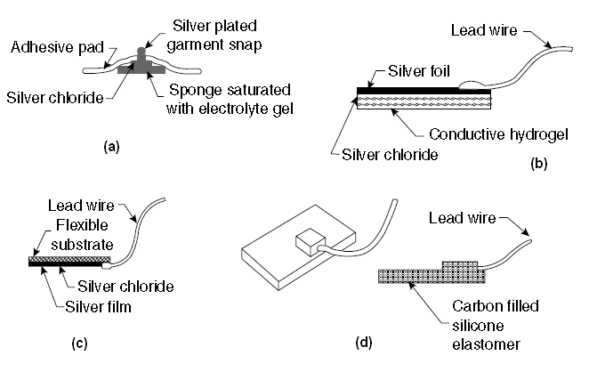
Figure 3.11.Examples of different skin electrodes. a) disposable electrode with electrolyte-impregnated sponge b) disposable hydrogel electrode c) Thin film electrode d) carbon-filled elastomeric dry electrode.

Thin-film flexible electrodes such as shown in Figure 3.11.c have been used for monitoring neonates. They are basically the same as the metal plate electrodes; only the thickness of the metal in this case is less than a micrometer. These metal films need to be supported on a flexible plastic substrate such as polyester or polyimide. The advantage of using only a thin metal layer for the electrode lies in the fact that these electrodes are x-ray transparent. This is especially important in infants where repeated placement and removal of electrodes, so that x-rays may be taken, can cause substantial skin irritation.

Electrodes that do not use artificially applied electrolyte solutions or gels and, therefore, are often referred to as dry electrodes have been used in some monitoring applications. These sensors as illustrated in Figure 3.11.d can be placed on the skin and held in position by an elastic band or tape. They are made up of a graphite or metal-filled polymer such as silicone. The conducting particles are ground into a fine powder, and this is added to the silicone elastomer before it cures so to produce a conductive material with physical properties similar to that of the elastomer. When held against the skin surface, these electrodes establish contact with the skin without the need for an electrolytic fluid or gel. In actuality such a layer is formed by sweat under the electrode surface. For this reason these electrodes tend to perform better after they have been left in place for an hour or two so that this layer forms. Some investigators have found that placing a drop of physiologic saline solution on the skin before applying the electrode accelerates this process. This type of electrode has found wide application in home infant cardiorespiratory monitoring because of the ease with which it can be applied by untrained caregivers.

Dry electrodes are also used on some consumer products such as stationary exercise bicycles and treadmills to pick up an electrocardiographic signal to determine heart rate. When a subject grabs the metal contacts, there is generally enough sweat to establish good electrical contact so that a Lead I electrocardiogram can be obtained and used to determine the heart rate. The signals, however, are much noisier than those obtained from other electrodes described in this section.

3.4.4.3 Intracavitary and Intratissue Electrodes

Electrodes can be placed within the body for biopotential measurements. These electrodes are generally smaller than skin surface electrodes and do not require special electrolytic coupling fluid, since natural body fluids serve this function. There are many different designs for these internal electrodes, and only a few examples are given in the following paragraphs. Basically these electrodes can be classified as needle electrodes, which can be used to penetrate the skin and tissue to reach the point where the measurement is to be made, or they are electrodes that can be placed in a natural cavity or surgically produced cavity in tissue. Figure 3.12 illustrates some of these internal electrodes.

A catheter tip or probe electrode is placed in a naturally occurring cavity in the body such as in the gastrointestinal system. A metal tip or segment on a catheter makes up the electrode. The catheter or, in the case where there is no hollow lumen, probe, is inserted into the cavity so that the metal electrode makes contact with the tissue. A lead wires down the lumen of the catheter or down the center of the probeconnects the electrode to the external circuitry.

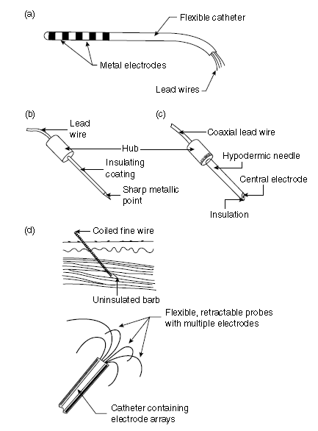
Figure 3.12.Examples of different internal electrodes. (a) Catheter or probe electrode (b) needle electrode (c) coaxial needle electrode (d) coiled wire electrode

The basic needle electrode shown in Figure 3.12.b consists of a solid needle, usually made of stainless steel, with a sharp point. An insulating material coats the shank of the needle up to a millimeter or two of the tip so that the very tip of the needle remains exposed. When this structure is placed in tissue such as skeletal muscle, electrical signals can be picked up by the exposed tip. One can also make needle electrodes by running one or more insulated wires down the lumen of a standard hypodermic needle. The electrode as shown in Figure 3.12.c is shielded by the metal of the needle and can be used to pick up very localized signals in tissue.

Fine wires can also be introduced into tissue using a hypodermic needle, which is then withdrawn. This wire can remain in tissue for acute or chronic measurements. Caldwell and Reswick and Knutson et al. have used fine coiled wire electrodes in skeletal muscle for several years without adverse effects.

The advantage of the coil is that it makes the electrode very flexible and compliant. This helps it and the lead wire to endure the frequent flexing and stretching that occurs in the body without breaking.

The relatively new clinical field of cardiac electrophysiology makes use of electrodes that can be advanced into the heart to identify aberrant regions of myocardium that cause life threatening arrhythmias. These electrodes may be similar to the multiple electrode probe or catheter shown in Figure 3.12.a or they might be much more elaborate such as the “umbrella” electrode array in Figure 3.12.d In this case the electrode array with multiple electrodes on each umbrella rib is advanced into the heart in collapsed form through a blood vessel in the same way as a catheter is passed into the heart. The umbrella is then opened in the heart such that the electrodes on the ribs contact the endocardium and are used to record and map intracardiac electrocardiaogram. Once the procedure is finished, the umbrella is collapsed and withdrawn through the blood vessel. A similar approach can be taken with an electrode array on the surface of a balloon. The collapsed balloon is advanced into one of the chambers of the heart and then distended. Simultaneous recordings are made from each electrode of the array, and then the balloon is collapsed and withdrawn.
3.4.4.4. Microelectrodes

The electrodes described in the previous paragraphs have been applied to studying bioelectric signals at the organism, organ, or tissue level but not at the cellular level. To study the electric behaviour of cells, electrodes that are themselves smaller than the cells being studied need to be used. Three types of electrodes have been described for this purpose: etched metal electrodes, micropipette electrodes, and metal-film-coated micropipette electrodes. The metal microelectrode is essentially a sub miniature version of the needle electrode described in the previous section (Figure 3.13.a). In this case, a strong metal wire such as tungsten is used. One end of this wire is etched electrolytically to give tip diameters on the order of a few micrometers. The structure is insulated up to its tip, and it can be passed through the membrane of a cell to contact the cytosol. The advantage of this type of electrode is that it is both small and robust and can be used for neurophysiologic studies. Its principal disadvantage is the difficulty encountered in its fabrication and high source impedance [15].

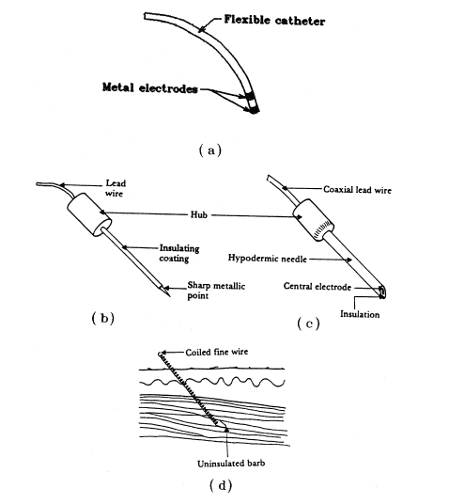
Figure 3.13.Microelectrodes a) metal b) micropipette c) thin metal film on pipette.

The second and most frequently used type of microelectrode is the glass micropipette. This structure, as illustrated in Figure 3.14.b consists of a fine glass capillary drawn to a very narrow point and filled with an electrolytic solution. The point can be as narrow as a fraction of a micrometer, and the dimensions of this electrode are strongly dependent on the skill of the individual drawing the tip. The electrolytic solution in the lumen serves as the contact between the interior of the cell through which the tip has been impaled and a larger conventional electrode located in the shank of the pipette. These electrodes also suffer from high source impedances and fabrication difficulty.

A combined form of these two types of electrodes can be achieved by depositing a metal film over the outside surface of a glass micropipette as shown in Figure 3.14.c. In this case, the strength and smaller dimensions of the micropipette can be used to support films of various metals that are insulated by an additional film up to a point very close to the actual tip of the electrode structure. These electrodes have been manufactured in quantity and made available as commercial products. Since they combine the features of both the metal and the micropipette electrodes, they also suffer from many of the same limitations. They do, however, have the advantage of flexibility due to the capability of being able to make films of different metals on the micropipette surface without having to worry about the strength of the metal, as would be the case if the metal were used alone [16].

3.5. Summary

An electrocardiograph is a device that measures and records the electrocardiogram (ECG), the electrical activity generated by the heart. Electrodes placed on special locations on the body help conduct the ECG to the electrocardiograph. The electrical current generated by the heart is conducted through the pairs of electrodes and leads, and is amplified, recorded, and processed by the electrocardiograph. Each electrode is special to take signal from body according to location of body such as microelectrode. The different features and modules of a typical electrocardiograph include the protection circuitry, preamplifier, memory system, micro controller and communication module.

The protection circuit prevents any damage due to high voltages that may appear as inputs to the electrocardiograph. The preamplifier stage consists of a different amplifier with a high CMRR (Common mode rejection ratio). The high CMRR ensures that any potential on the patient’s body that is common to both inputs of the differential amplifier is not amplified by the electrocardiograph.

The input of the driver amplifier circuitry is ac-coupled and this prevents the output of further amplifier stages from saturating due to the offset in the input signal. The ECG is then filtered with an upper corner frequency (3 dB) of 150 Hz and amplified sufficiently so that it can be recorded. Modern electrocardiographs include an analog-to-digital converter (ADC) to digitize the signal. Data segments of the ECG from each lead, and other relevant information of the patient can be stored in memory. A microcomputer in the electrocardiograph also enables the operator to select leads to record, process ECG signals, perform preliminary arrhythmia analysis and other related tasks.

CHAPTER 4
PULSE OXIMETRY
4.1. Overview
Pulse oximetry or SPO2 is a non-invasive method allowing the monitoring of the oxygenation of patients’ haemoglobin level in the blood and in addition calculating heart rate. Therefore, pulse oximeters are generally used for this purpose, as well as it is integral part of numerous medical procedures, including patient monitoring in the operating room and intensive care situations, pulmonary evaluations, and neonatal diagnoses, oral surgeries, and the use of general anesthesia.
In a pulse oximeter system, a clip with optical electronics is usually attached to finger, toe, or ear so that light can be transmitted through the skin from one side of the clip and received on the other side with a photodiode. Good arterial blood flow is required to measured oxygen saturation with haemoglobin cells. Generally, most of pulse oximeter applications use optical techniques such as led and infra-red (IR) system.
4.2. Principles of Pulse Oximetry
A typical Pulse Oximeter uses the basic principle of a pair of small LEDs operating at two different wavelengths; one red LED with a wavelength of 660nm, the other, an infrared LED with a wavelength of 910nm. The LEDs are designed to be placed opposite a photodiode that detects the light from the LEDs. Absorption on each wavelength differs significantly for the oxyhaemoglobin and deoxygenated haemoglobin. Therefore from the difference of the absorption of the red and infrared light the ratio between oxy/deoxyhaemoglobin can be calculated. As the amount of blood in the capillaries depends on the actual blood pressure, which varies around the heart pulse cycle, the heart rate can also be measured.
Haemoglobin (Figure 4.1) is an active oxygen carrying part of the red cells which is a compound of iron and four polypeptide chains. Each chain is linked to one atom of iron, each of which can carry four molecules of oxygen. Each molecule of oxygen has two atoms of oxygen so each haemoglobin molecule can carry eight atoms of oxygen.

Oxyhaemoglobin refers to oxygen carrying haemoglobin and deoxygenated haemoglobin refers to nonoxygenated haemoglobin. If all haemoglobin molecules bonded with an oxygen molecule, the total body of haemoglobin is said to be fully saturated (100% saturation). When haemoglobin unloads the oxygen molecule to tissue cells at capillary levels, the saturation progressively decreases and the normal venous saturation is about 75%. The normal saturation level is said to be between 87-97%.
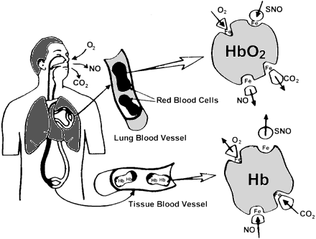
Figure 4.1.Haemoglobin and Oxygen transportation.
The two wavelengths are selected for the reason that deoxygenated haemoglobin has a higher absorption at around 660nm and at 910nm oxygenated haemoglobin has the higher absorption. The oxygenated haemoglobin allows red light to transmit through and absorbs more infrared light while the deoxygenated haemoglobin allows infrared to transmit through and absorbs more red light.
Figure 4.2.Absorption coefficient for two types.
Generally a finger is placed between the source (LEDs) and the receiver (photodiode) acting as a translucent site with good blood flow. Once these absorption levels are detected from the finger the ratio of absorption at different wavelengths can be obtained.
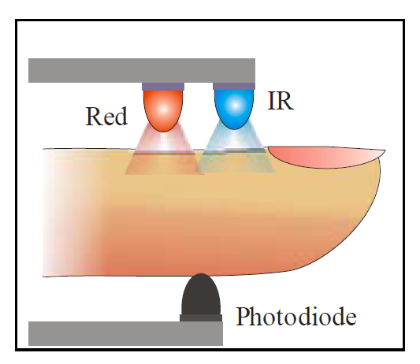
Figure 4.3.Schematic of finger pulse oximeter idea.

The normal pulse oximeter waveform is shown in Figure 4.4. Red and infrared signals are modulated by the cycling blood volume in perfuse tissues. At high saturation of oxygen (SaO2), the red pulse amplitude (AC/DC where is AC is the alternating component and DC is the average component) is smaller than in the infrared while the relative amplitudes are reversed at low saturation. Note the signal shape is inverted from a blood pressure waveform. The incremental increase in the tissue blood concentration at systole results in less light reaching the photo detector than at systole [17].
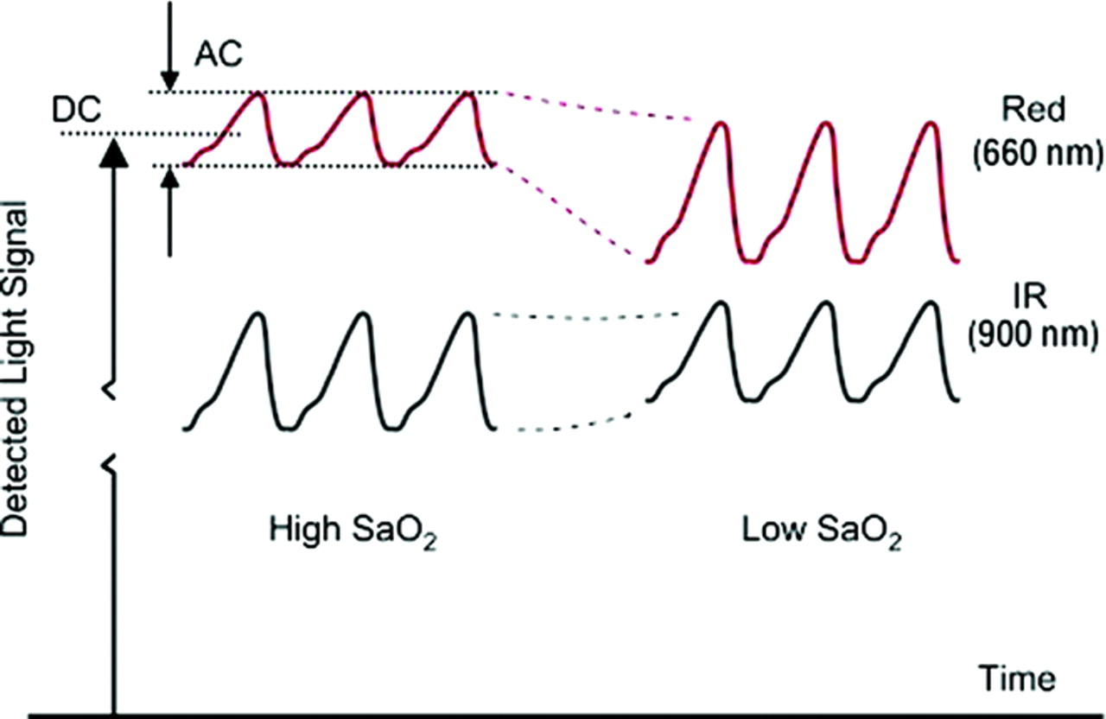

Figure 4.4.Normal detected light signal in Red and infrared for SpO2.
Haemoglobin bound to oxygen called oxygenated haemoglobin (HbO2) and Haemoglobin not bound to oxygen is called deoxygenated haemoglobin (Hb). The oxygen saturation is the ratio of the oxygenated haemoglobin to the haemoglobin in the blood, as defined by the following equation.
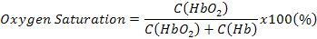
Where C(Hb)=Concentration of deoxygenated haemoglobin.
=Concentration of oxygenated haemoglobin.

4.3. History of Pulse Oximetry
Oximetry is the measurement of transmitted light through a translucent measuring site to determine a patient’s oxygen status noninvasively. Oximetry measurements can be traced to the early 1930’s when German investigators used spectrophotometers (instrument that measure different wavelengths and intensities of light) to research light transmission through human skin. In 1934, one investigator reported measuring oxygen saturation in blood flowing through closed vessels in animals.
In 1939, German researchers showed the use of an oxygen meter that used red and infrared light to compensate for changes in tissue thickness, blood content, light intensities and other variables. After three years then, a British researcher, Millikan, used two wavelengths of light to produce a practical, lightweight aviation finger oxygen meter for which he coined the word oximeter. He noted that light transmitted through a red filter was oxygen-saturation-sensitive and light passing through a green filter was independent of oxygen saturation. It was later determined that oxygen insensitive signals were-not due to the green light filter but instead to infrared light.
Following to ground work of the early scientist; wood and Shaw further developed the principles of the pulse oximeter during 1940 to 1964. In 1972, Takuo Aoyagi, a Japanese bio-engineer, invented the pulse oximeter after measuring oxygen saturation by sending light through the tissues. In the late 1970’s, Biox corporation in Colorado made significant advances in pulse Oximetry, 2 wavelength measurements. They first introduced the use of Light Emitting Diodes (LED’s) for the red and infrared light sources [18].
Since the early 1980’s, this non-invasive method of monitoring the arterial oxygen saturation level in patient’s blood has become a standard method in the clinical environment because of its simple application and the high value of the information it provides. Before the advent of pulse Oximetry, the common practice was to draw blood from patients and analyse the samples at regular intervals- several times a day, or even several times an hour- using large hospital laboratory equipment. The most common pulse oximeters still use the 2-wavelength method of light transmission. A big advantage of small fingertip pulse oximeters today is their small size, recording capability and computer connectivity capability. A new generation pulse Oximetry is shown in Figure 4.5 which is used in hospital.
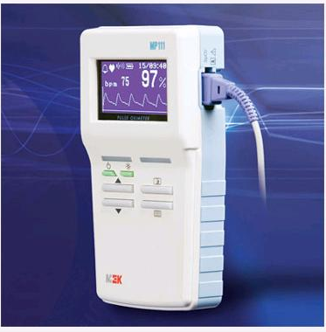
Figure 4.5.Browse hand held Pulse Oximetry [19].
4.4. Pulse oximeter instrumentation
A basic block diagram of circuit for a pulse oximeter is shown in figure 4.6.
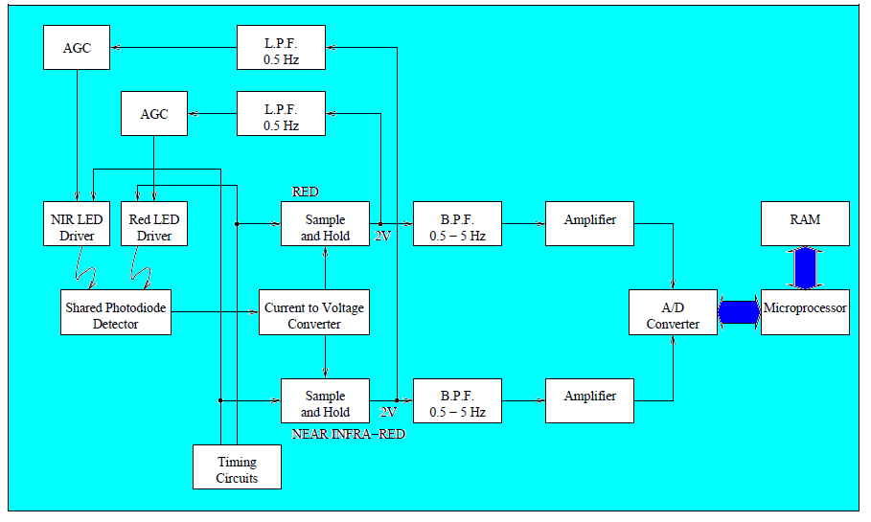
Figure 4.6.Block diagram of Finger tip pulse oximeter [20].

In order to build finger (or earlobe) probes which are small and unobtrusive, we need miniature light sources and detectors. LEDs which work in the red and Near-Infrared (NIR) part of the spectrum are readily available. However, the average power which can be obtained from standard LEDs is limited and a very sensitive detector (such as a photomultiplier tube) would be required to detect the small amount of light transmitted through the finger.
This problem can be overcome by using special- purpose LEDs which have been developed: red LEDs are now manufactured with internal lensing systems to give high intensity outputs. Similarly, high current NIR LEDs are designed to be pulsed so that the peak power available from them can be increased without increasing the average power. This makes it possible to detect the light transmitted through the finger with a simple, compact, solid-state photodetector such as photodiode.
If we pulse both light sources, we can then use a single photodetector in the finger probe, since silicon devices are responsive to light having visible and NIR wavelengths. We could, for example, use timing circuits to supply, say, 50µs pulses to the red and NIR LED drivers at a repetition rate of 1 kHz, as shown Figure 4.7.
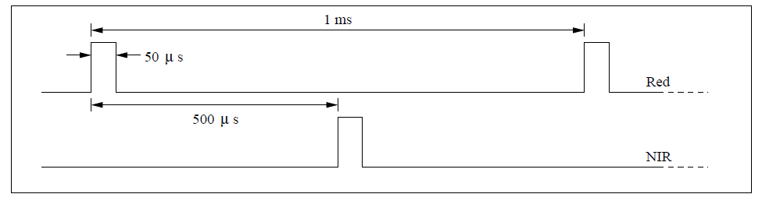
Figure 4.7.Timing signals for the LED drivers such as red and infrared.
In this mode of operation, high-intensity light outputs can be obtained with the NIR LED with currents of up to 1A over a low duty cycle. The transmitted light detected by the photodiode is amplified and converted. At this point in the circuit the signal is fed to two identical sections, one for each of the transmitted wavelengths.
Since the light is pulsed, we need to use a sample-and-hold circuit to reconstitute the waveforms at each of the two wavelengths. The same timing circuits which were used to control the red and NIR LED drivers are also used to provide the control pulses for the corresponding sample-and-hold circuits. The output from these circuits is then filtered with a band-pass filter (with 0.5 Hz and 10 Hz cut-off frequencies) in order to remove primarily the DC component but also high frequency noise. The resulting signals thus represent the cardiac-synchronous information in the waveforms and these are further amplified before they are converted to digital format for subsequent analysis by the microprocessor [21].
4.5. Summary
A pulse oximeter measures the amount of oxygen in a patient’s blood by in patient’s blood by sensing the amount of light absorbed by the blood in capillaries under the skin in human blood. In a typical device, a sensing probe is attached to the patient’s finger with a spring-loaded clip or an adhesive band. On one side of the probe is a pair of Light - Emitting diodes (LEDs) and on the other side is a photodiode. One of the LEDs produces red light and the other produces infrared light. Pulse Oximetry depends on the optical characteristics of haemoglobin, the blood protein carries oxygen. When haemoglobin is more highly oxygenated, it becomes more transmissive to red light and more absorptive to infrared light. When haemoglobin contains little oxygen, it becomes relatively more transmissive to infrared, and more absorptive to red light. This property means that by measuring the ratio of red light to infrared light passing through the patient’s finger, the probe can produce a signal proportional to the amount of oxygen in blood. In addition, the surge of blood on each heart beat generates a signal representative of the patient’s pulse rate.

CHAPTER 5
MEDICAL TELEMETRY SYSTEMS
5.1. Overview
Medical Telemetry is a method of measuring biological parameters from a distance. It is in fact modification of existing methods of measuring physiological variables to a method of transmission of resulting data. The transmission of data from the point of generation to the point of reception can be done in various ways. In medical telemetry, the measurements as analog signals in suitable form are transmitted which are received and decoded as actual measurements at the receiving end. A medical telemetry system basically consists of transmitter and receiver or decoder.

5.2. General Description of Medical Telemetry.
Medical Telemetry is the wireless transmission of automatically measured physiological data from the point of sensing to a remote location. Medical Telemetry is a vital constituent in the field of medical sciences. Use of wires to transmit data may be eliminated by wireless technology. Medical Telemetry, using wireless diagnosis, can monitor electronically the symptoms and movement of patients. In medical telemetry we transmit the measured signal to a remote place by means of a medium for communication. A radio wave is a typical example of the medium.
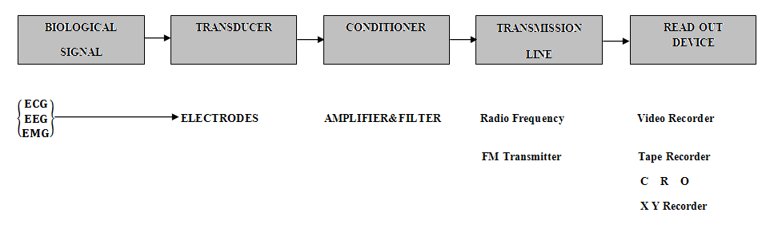
Figure 5.1.Block diagram of Medical telemetry system.

The essential blocks of a medical telemetry system are shown in Figure 5.1. Any quantity that can be measured in the biomedical field is adaptable to medical telemetry system. Bioelectrical parameters include measurements like electrocardiogram (ECG), electromiyogram (EMG), and Electroencephalogram (EEG). In the medical telemetry system biological parameters is taken from human body with transducers. Transducer is a substance or device, such as piezoelectric cell, electrodes, thermocouple, thermistor, convert biological variables into an electrical signal. Parameters are measured as the variation of resistance, capacitance and inductance. The signal conditioner amplifies and modifies this signal for effective transmission. Transmission line connects the signal input blocks to the read-out device by wire or wireless means.

5.3. Brief History of Medical Telemetry Systems.
In the early days of human space flight, National American Space Association (NASA) utilized medical telemetry to provide biomedical data from orbiting astronauts to medical personnel at the NASA Johnson Space Center (Manned Space Flight enter in the early 1960’s). Biomedical data transmitted to Earth from space included astronauts heart rate, body temperature, ECG, Oxygen () and carbon dioxide () concentration. Further research and technology from NASA was instrumental in driving telemetry and medical telemetry into civil health care.

Distance medicine has been around for most of this century. In the early days, doctors treated patients in remote locations via wireless radio and by sending diagnostic samples through the mail. Today, communication is done digitally, and it is called medical telemetry. On an extended space flight, the need to consult, diagnose and deliver effective medical care when the doctor is far away from the patients is crucial. Scientists are developing hardware and software to facilitate this process.

5.4. Types of Medical Telemetry Systems
5.4.1. Single Channel Medical Telemetry Systems.
Electrocardiogram is the most commonly monitored medical condition sent by wireless telemetry. It is known that monitoring of the ECG and cardiac rate gives sufficient information on the loading of the cardiovascular system.

Figure 5.2 shows the block diagram of a single channel telemetry system suitable for transmission of electrocardiogram. The telemetry transmitter which consist of ECG amplifier, sub-carrier oscillator and UHF transmitter along with dry cell batteries. Telemetry Receiver, consisting of a high frequency unit and a demodulator, to which an electrocardiograph can be connected to record, a cardioscope to display and a magnetic tape recorder to store ECG. A heart rate meter with an alarm facility can be provided to monitor continually beat-to-beat heart rate of subject.
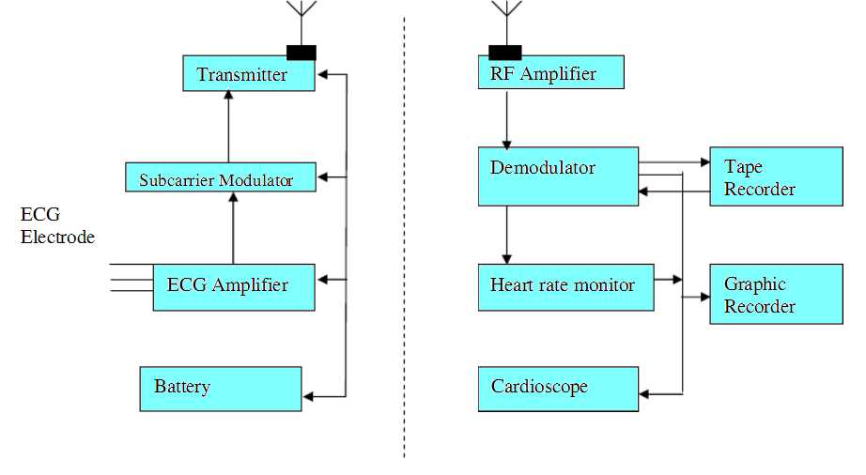
Figure 5.2.Block diagram of a single channel telemetry system.

Some ECG telemetry systems operate in the 450-470 MHz band, which is well-suited for transmission within a hospital and has the advantage of having a large number of channels available.

5.4.2. Multi channel medical telemetry systems
Medical measuring problems often involve the simultaneous transmission of several parameters. For this type of application, multi-channel telemetry system is employed. Multi-channel telemetry is particularly useful in athletic training programs as it offers the possibility of surveying simultaneously several physiological parameters of the person monitored.

With appropriate preamplifiers, the multi channel systems permit the transmission of the following parameters simultaneously depending upon the number of channels required, ECG and heart rate, respiration rate, temperature, intravascular and intra-cardiac blood pressure.

In multichannel telemetry, the number of subcarriers used is the same as the number of signals to be transmitted. Each channel therefore has its own modulator. The RF unit-the same for all channels-converts the mixed frequencies into the transmission band. Similarly, the receiver unit contains the RF unit and one demodulator for each channel. Pulse width modulation is better suited for multichannel biotelemetry systems. Such systems are insensitive to carrier frequencies shifts and have high noise immunity. FM-FM system for similar use, though may have low power consumption and high base line stability, they are more complicated and turn out to be more expensive. They can be troubled by interference.

Figure 5.2.FM-FM modulated radio telemetry transmitter for ECG.

5.5. Summary

Medical telemetry is defined as a way to transmit data electronically from one point to another. In the medical telemetry system, machines record electronic data related to each patient. Specific body functions are measured using transducers, which convert biological variables into electrical signals. These signals are amplified using suitable instrumentation amplifiers. Then, the signal is converted into digital form and sent using a wireless transmitter. The receiving system receives the signals with an antenna, converts them into suitable form and then displays them. Telemetry systems can be singles a multichannel. In the single telemetry systems, one signal is sent, where in multichannel systems, more than one signal is sent.

,

CHAPTER 6
DESIGN OF A MEDICAL TELEMETRY SYSTEM

6.1. Overview
Electrocardiogram and oxygen saturation level in blood are very crucial for human life. For this reason, in emergency conditions, these parameters must be sent very quickly as every second is very important to patient’s life. Therefore, Medical Telemetry is used for sending these parameters or other biological parameters. This chapter describes the medical telemetry system designed and developed by the author.

6.2. Medical Telemetry System.
The block diagram of the medical telemetry system designed and developed by the author is shown in Figure 6.1.
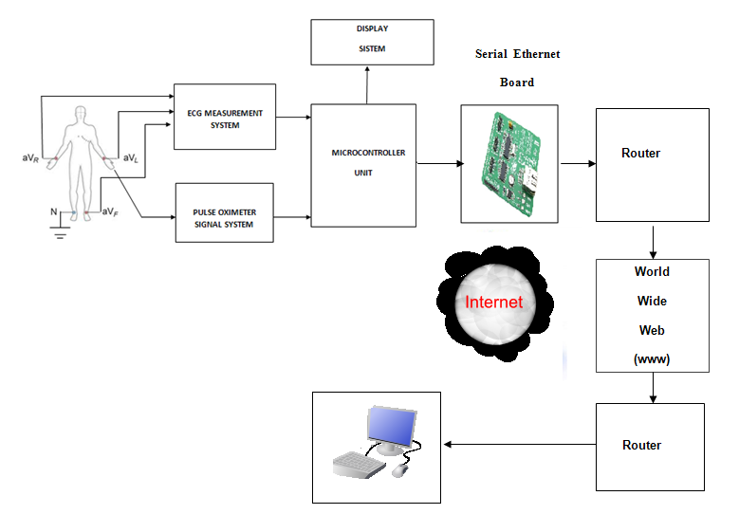
Figure 6.1.Block diagram of medical telemetry design system.
In the medical telemetry system, two biological parameters were measured such as ECG and oxygen saturation level (pulse Oximetry) in blood. This system was designed of two parts like hardware and software.

Medical telemetry system hardware includes two main components: microcontroller unit and serial Ethernet board, used for taking biological parameters from the patient as electrical signals and then sending the digital data over the Ethernet.

The measurement system was designed to obtain ECG and and these signals. Transmitter system consists of ECG and measurement circuit board which takes signals from the human body. Transmitter system consists of three parts such as ECG measurement unit, pulse oximeter system, and Ethernet system. Firstly, ECG measurement system was designed and its block diagram is shown in the Figure 6.2.
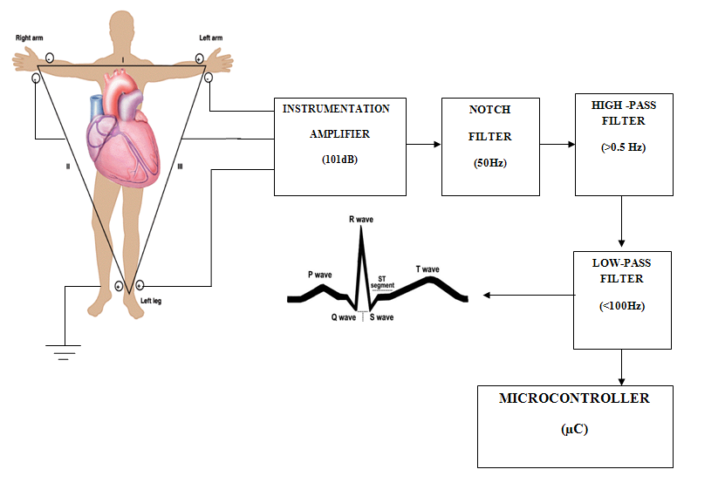
Figure 6.2.Block diagram of the designed ECG measurement system.

6.2.1. The ECG Measurement System
The ECG measurement system circuit diagram is shown in the Figure 6.3. SMPS power supply was used to protect patient from short circuit with an isolation amplifier. Electrical activity of heart was obtained from the skin on human body (right arm (RA), left arm (LA) and right leg) with suction type electrodes. ECG electrodes were placed as standard limb and were connected to the instrumentation amplifier with three electrodes and one ground line.

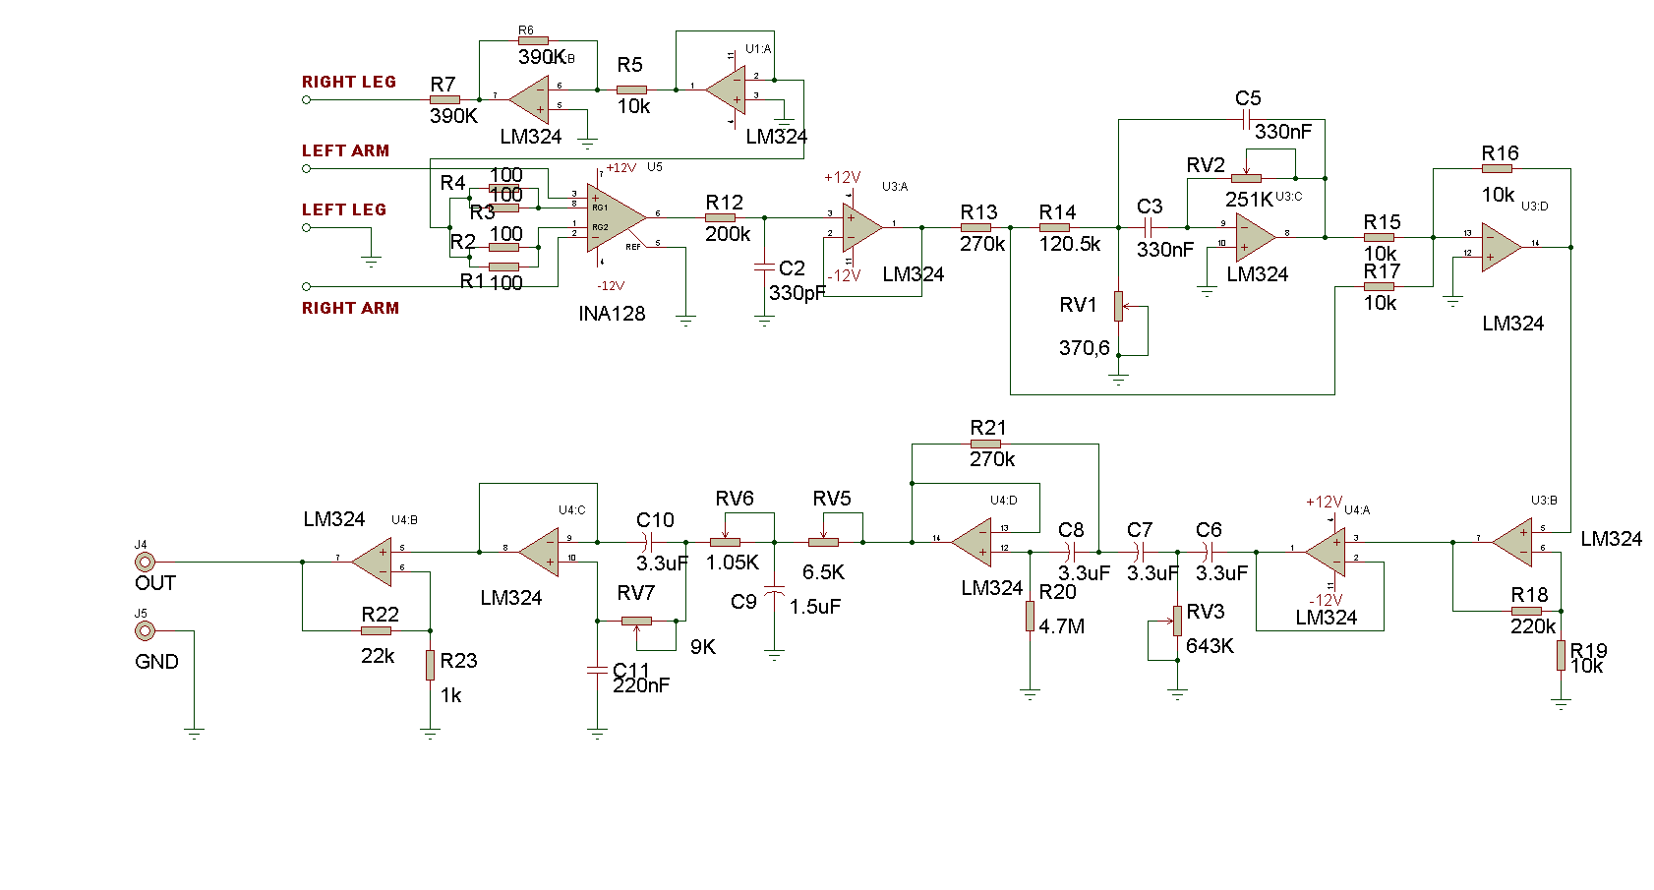
Figure 6.3.ECG measurement system circuit diagram.

INA128 (Appendix A) was selected and used as the instrumentation amplifier because it has very low input voltage operation (a several µV), high CMRR (120dB) and low output resistance. In the INA128 instrumentation amplifier, input resistor was selected as 25Ω and then gain was calculated using the formula given below (see the datasheet);

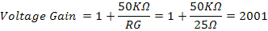
And as dB,

Right leg driver circuit was used to eliminate interference noise by actively cancelling the interference. The output of the ECG signal from INA128P, which includes electrical noise, can be seen in Figure 6.4.
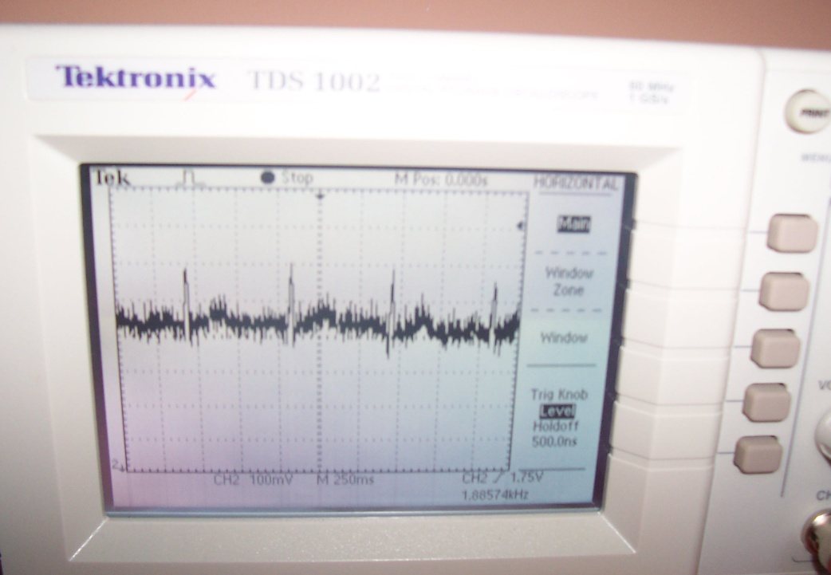

Figure 6.4.The output ECG signal from INA128KP

Signal filtering is necessary to help isolate the frequencies found in the ECG signal from the noise. With three lead systems, the majority of the noise comes from the electrical activity in the muscles on the arm, or electromyography (EMG) noise. EMG signals are present in a wide frequency band which overlaps with the ECG signal in the lower frequencies. For this reason, it is impossible to completely remove EMG noise from the ECG signal. Therefore, it was helpful for the patients relax and remain still while the data was being collected. The ECG signals were amplified by the instrumentation amplifier and fed into the noise filtering circuits consisting of different stages. The first stage was notch filter which was used to eliminate corrupting power line frequency noise in the ECG signal. The design of the notch filter is shown in the Figure 6.5.
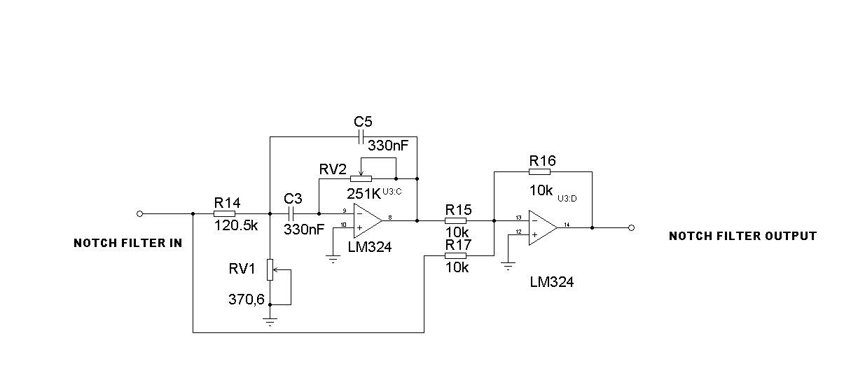
Figure 6.5.Notch filter circuit for ECG.

The notch filter was designed with a cut-off frequency of 50 Hz and then summing amplifier was used to remove 50Hz noise. When the trimmers were set to RV1=370.6Ω, RV2=251K, and capacitors to C3=C5=330pF, the cut off frequency was measured to be 50Hz.

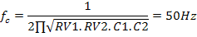

Before the notch filter, signal level was reduced because the signal was amplified 22 times by the inverting amplifier. The second stage was designed as Second order Sallen-Key Butterworth high pass filter (Figure 6.6) with cut-off frequency set to 0.043Hz to eliminate very low undesired noise signals as in some applications, the QRS wave was seen between 0.05 to 1 Hz. Sallen-Key Butterworth type low pass and high pass filter were used because they have the flattest possible pass-band magnitude response [21]. The cut off frequency is calculated with R20, R21, C7, and C8 and was obtained as 0.043 Hz using following equation.
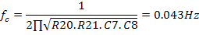
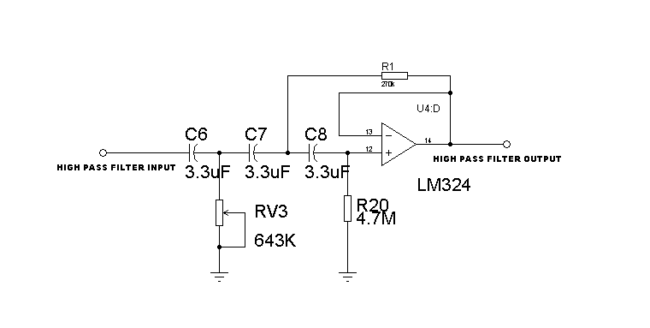
Figure 6.6.Sallen-Key Butterworth high pass filter for ECG.

The maximum frequency component present in the ECG signal is around 250 Hz. But a cut-off frequency of 100 Hz is usually sufficient and is often used in the design low pass filters in ECG applications. For this reason, the third or last stage of modified Sallen-Key Butterworth low pass filter (Figure 6.7) was set to 100Hz to reject high frequency undesirable signals When RV6=1.05KΩ, RV7=9KΩ, C10=3.3µF, C11=220nF, the cut off frequency was obtained as 100 Hz using the following equation. Figure 6.8 shows the filtered signal as a clear signal.

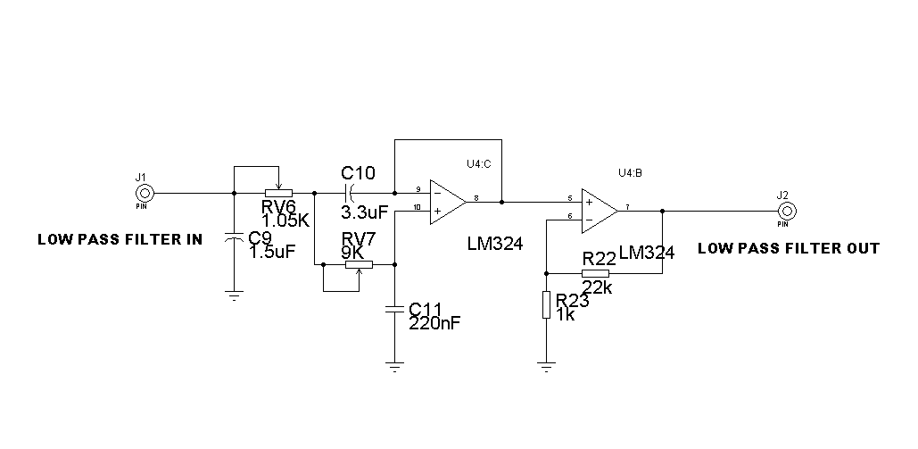
Figure 6.7.Modified Sallen-Key Butterworth low pass filter for ECG.
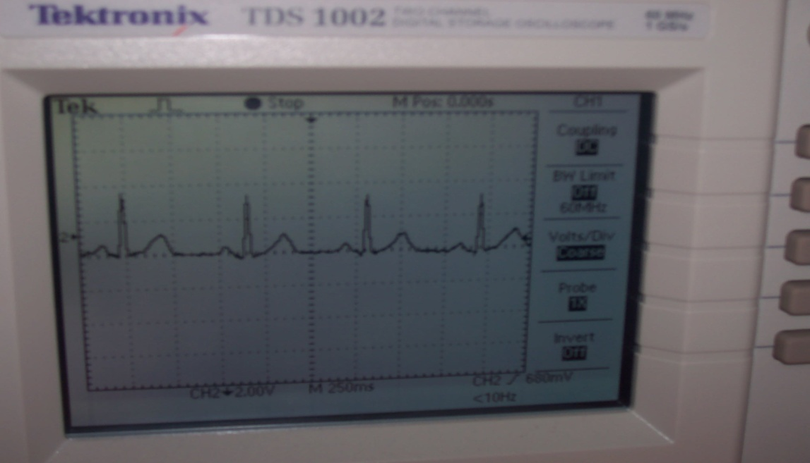

Figure 6.8.Output signal of ECG measurement system.

6.2.2. Pulse Oximeter System.
A block diagram of the designed pulse oximeter system is shown in the Figure 6.9.

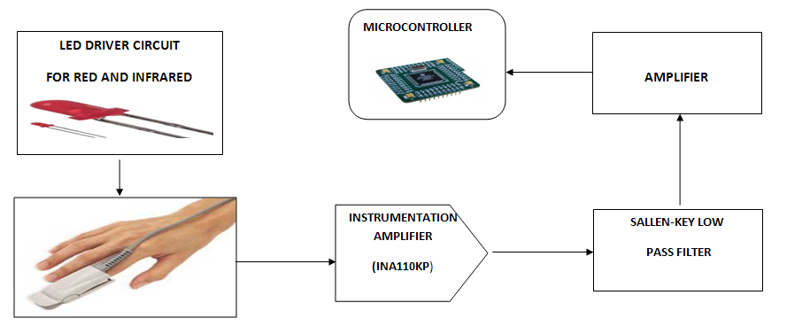
Figure 6.9.Block diagram of the designed finger tip pulse oximeter system.

Pulse Oximeter is an opto-electronic non-invasive medical instrument, capable of measuring and recording the changes in SpO2 at the finger tip. Pulse oximeter system is used to measure the saturated oxygen level in the blood as this parameter is important and plays an important role in the oxygen transportation in the body. Haemoglobin shows different absorption effects for red and Infra-red lights and this difference effect is shown in the output signal of the pulse oximeter. (Figure 6.10).

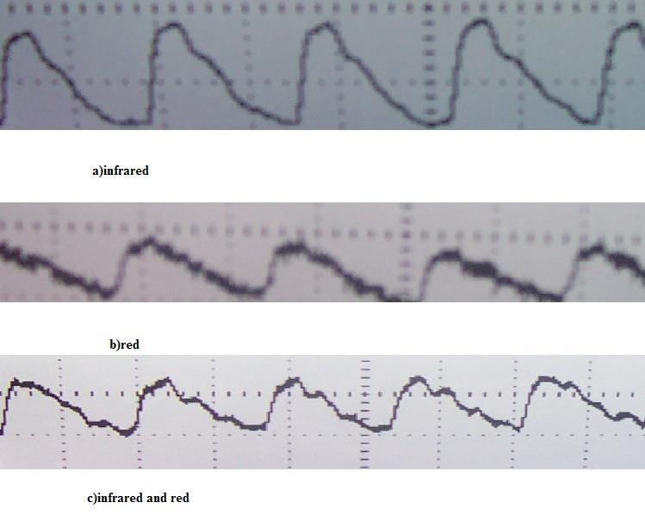

Figure 6.10.The output signal for red and infra-red light

LED driver circuit was used for red and infra-red driving in every 500µS because this pulse rate was optimal for driving the Nellcor pulse oximeter probe. A 555 timer circuit was used to generate pulse, and the pulse length was adjusted with resistors and capacitors. The 555 timer circuit and pulse signal are shown in the Figure 6.11.
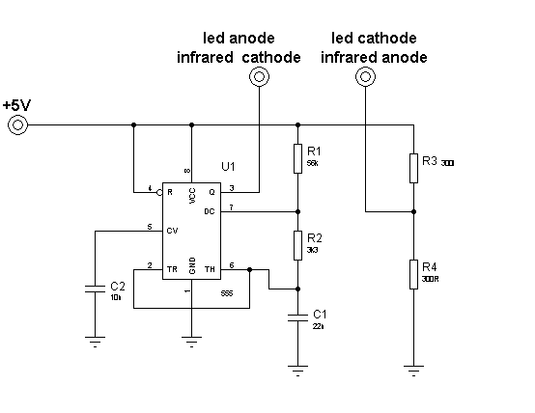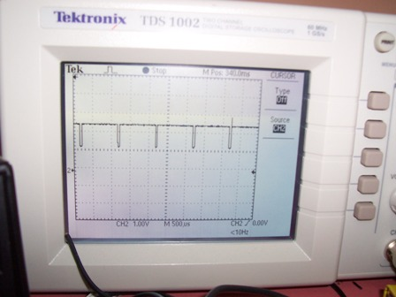

Figure 6.11.Bipolar 555 timer circuit (a) and pulse signal in oscilloscope (b).

LED driver circuit was connected to Nellcor pulse oximeter probe which produced signal in 9 pin D-SUB male connector (Appendix B). Nellcor pulse oximeter probe is basically produced from one LED pair and one photodiode. Nellcor pulse oximeter probe connection with instrumentation amplifier is shown in the Figure 6.12.
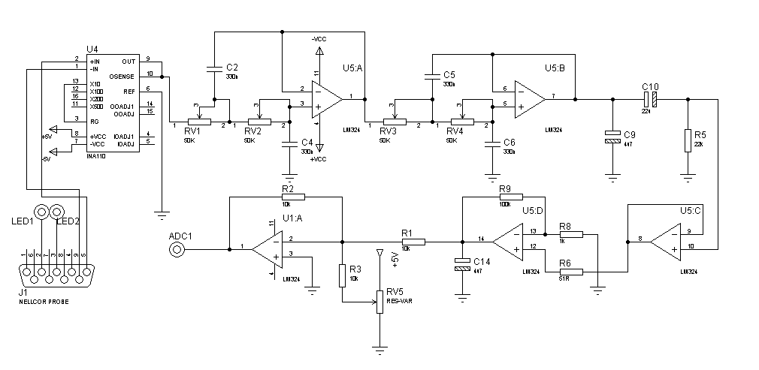Figure 6.12.Pulse oximeter circuit with Nellcor probe connection.

Burr Brown INA110KP was selected as the instrumentation amplifier due to its high CMRR rate and low voltage operation. It’s very high input impedance and low input bias current make the INA110KP ideal for applications requiring input filters or input protection circuitry. Because of selecting RG = 10, the voltage gain was 10, or 20dB in decibel due to the instrumentation amplifier. Photodiode was connected between positive and negative inputs of the current to voltage converter which was used for fixing to current change. The output signal of instrumentation amplifier, which is includes high frequency signals, was obtained which is shown in the Figure 6.13.
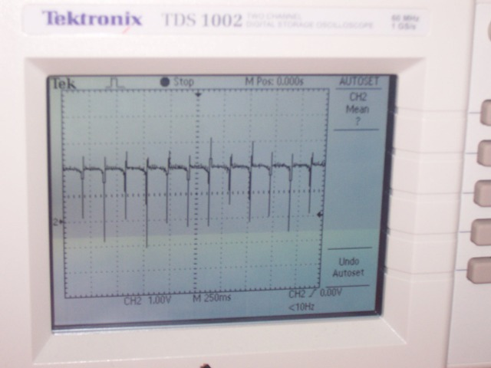
Figure 6.13.The output signal of INA110KP instrumentation amplifier circuit.

The noise signal was removed from the pulse oximeter signal with a second order Sallen-Key low pass filter, having a cut-off frequency of 10 Hz. Second order low pass Sallen-Key Butterworth low pass type filter was used two times to remove the noise from the LED and the infrared signals. Cut-off frequency was selected to be about 10 Hz because it was enough to remove the high frequency signals from the pulse oximetry measurements. Cut-off frequency was calculated with the following equation using RV1, RV2, C2, C4 and, cut-off frequency was obtained as 9.64Hz nearly 10Hz.
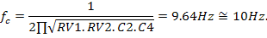

After using the low pass Sallen-Key filter twice, the signal was amplified and the final output waveform is shown in Figure 6.14. In the pulse oximeter system signal, outgrowth is symbolized as R wave signal in the ECG. In addition, the duration between peak to peak symbolizes the heart beat duration.

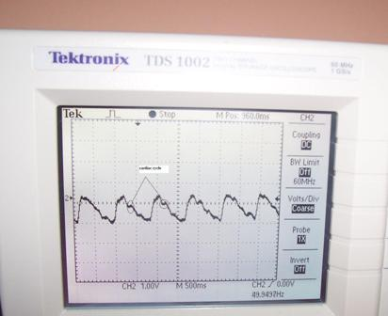

Figure 6.14.The output signal from Pulse oximeter system.

6.2.3. The Microcontroller system
DSPIC30F6014A was selected as the microcontroller due to its high performance with 12 bit Analog to Digital Converter (ADC). This is an 80-pin processor having large program memory. DSPIC30F6014A pin diagram is shown in Figure 6.15. The circuit diagram of the microcontroller and the Ethernet controller board are shown in Figure 6.16 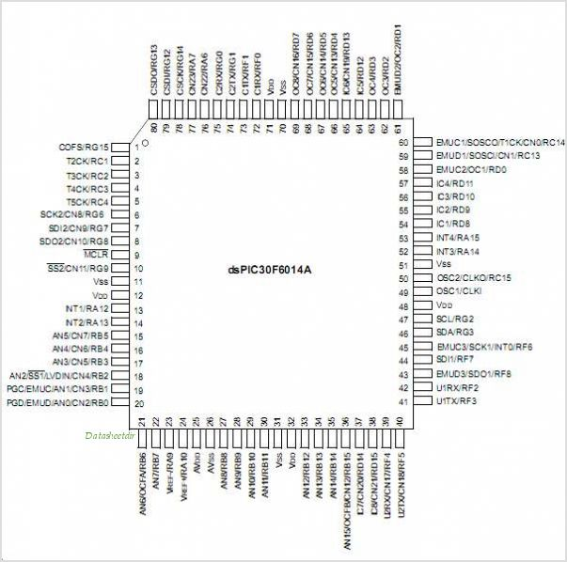
Figure 6.15.Pin diagram of DSPIC30F6014A.

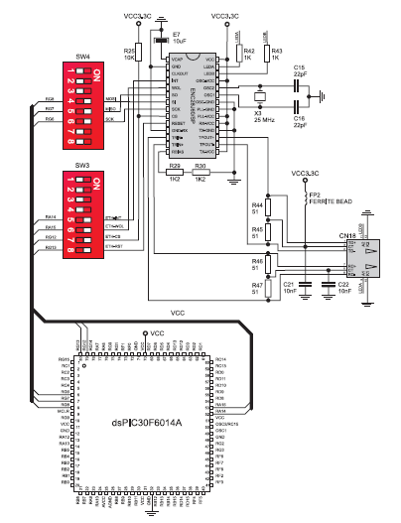
Figure 6.16.Microcontroller and serial Ethernet circuit diagram.

DSPIC30F6014 (dsPIC) was used as the main component of the system because all the biological data was collected and temporarily stored in it, and data was sent out from the processor using a serial Ethernet board. Power was provided from SMPSS power supply in 12V output. Data was taken with 12-bit ADC and meanwhile digital data, which was converted from analog ECG and pulse oximeter signals according to Nyquist theorem principle, were plotted on a 128x64 type graphics LCD (GLCD). According the Nyguist theorem digital sampling frequency must be at least twice the highest frequency component in the signal. Microcontroller oscillation was provided using a 10MHz crystal oscillator, and two capacitors. In addition, DSPIC30F6014A can be operated until 80 MHz for advanced applications such as digital signal processing. For data sending, Ethernet board system was used which employs a 28-pin ENC28J60 10BASE-T type stand-alone Ethernet controller chip that interfaces using the standard SPI serial bus, making it ideal for adding Ethernet to dsPICs and other microcontrollers that do not feature an on-chip Ethernet controller.

6.3. Software of Medical Telemetry System
The software of the Medical Telemetry System was written using the MikroBasic PRO for DSPIC 5.40 language because of its ease of use and large code library. Software was started with ADC control process and PORTB was defined as input. GLCD and Ethernet Board were declared according to GLCD connection and Ethernet board with DSPIC30F6014A. For plotting the captured signal continuously on the GLCD, GLCD_DOT instruction was used and horizontal and vertical axes calibrated accordingly.

In the Ethernet software, HTML code was embedded in program code and between the Ethernet board and destination board communication was provided with IPADRESS, like 168.68.20.1. Software listing is given in detail in Appendix C.

6.4. Summary
The medical telemetry system contains two important and crucial measurement systems, such as ECG and SPO2, or pulse oximeter signal. The ECG measurement system consists of one INA128KP as an instrumentation amplifier to amplify very low input signals, a notch Filter to eliminate 50Hz noise from the city electrical main supply, one low pass and one high pass filter to filter out the noise between 0.5Hz and 100Hz. The ECG signal was obtained from the skin surface with suction type electrodes. The second measurement system is the pulse oximeter system consisting of one instrumentation amplifier, and two second order low pass filters to eliminate upper frequencies from 10Hz. These two signals are collected with two 12-bit ADC in DSPIC30F6014A and data is sent using an Ethernet Board. Digitized data from ECG and pulse oximeter signals are displayed and monitored on a 128x64 pixel GLCD monitor.

CHAPTER 7

RESULTS AND DISCUSSION

A medical telemetry system has been designed and developed as a device that enables the study of the performance of ECG and blood oxygen saturation levels, by detecting the electrical activities in the body. The designed medical telemetry system presents faithful reproduction of the signals detected from the body, and makes them available for further processing by a doctor or a health specialist, located at distant locations.

The system is designed using readily available electronic components and software and it can be easily modified to suit different applications. It can serve for the data collection to help the doctor in work of ECG and pulse oximeter.

In the design of the medical telemetry system, two important parameters are measured such as ECG signal and Pulse Oximeter signal using electronic circuits. In the single channel ECG measurement system, ECG signal was taken from the body surface with suction type ECG electrodes which are made from Ag/AgCl. INA128KP is selected as the instrumentation amplifier because it has very low voltage operation, high CMRR and low output impedance. Careful selection and use of two second order Sallen-Key Butterworth filters provided a noise free signal. The filtered signal is converted into digital from by a microcontroller module. The microcontroller formats the signal and sends it to an Ethernet card for transmission over a network.

The main requirements of a medical telemetry system can be summarized as follows:

- Low cost
- Portable
- Battery operated
- Safe operation
- User friendly
- Fast
- Clean, noise free outputs
- Long distance transmission
- Capable of sending important medical parameters (e,g, ECG and SPO2)
- Accessible using network devices (e.g. mobile phones and iPAD)

The above are the basic requirements and additional requirements can be sought depending upon specific applications. The system designed and developed by the author satisfies all of the above requirements.

The data communication module in most commercially available medical telemetry systems are based on radio frequency (RF) techniques. Here, a pair of RF transmitter and receiver modules are used. This approach has the disadvantage that the signal can easily be contaminated by electromagnetic interference. In addition, the maximum distance that the signal can be sent depends upon power of the transmitter and is limited in most cases, and the signal is prone to attenuation. The system designed by the author on the other hand is based on the Ethernet which is not affected by electromagnetic noise. The maximum distance is also not a problem since the system can be accessed using a suitable network technology, such as a mobile phone or an IPAD.

The ECG output signal obtained from the system is shown in Figure 7.1. As can be seen from this figure, the output waveform is clean and is free from any electrical noise. This shows that the selection of the filtering circuits and the cut off frequencies have been acceptable. Addition of external knobs to adjust the filter frequencies could be a useful modification to the system to obtain clear and noise free waveforms in all applications.

The Heart Rate (HR) can easily be calculated by developing software to calculate the time between the waveform peaks, using for example microcontroller timer modules. Such information can be displayed at the bottom of the display to help doctors to quickly analyze the results.

In addition, the system can be miniaturized by using digital filters instead of analog filters used in the current design. Another advantage of using digital filters will be that the response will be independent of environmental effects such as the temperature, ageing, and component tolerances. The digital filtering modification will require the implementation of a digital filtering algorithm in the microcontroller and the addition of an external digital to analog converter module to the system.
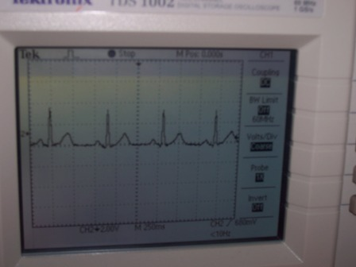
Figure 7.1.The output signal of the designed ECG system.

Second designed measurement system is the pulse oximeter that provides non-invasive and continuous information about the percent of oxygen that is combined with haemoglobin in the blood. A pulse oximeter is often referred to as a hypoxemia monitor because it can continuously reflect changes in a patient’s arterial oxygen saturation. In the system designed by the author, this part of the system was designed using an instrumentation amplifier and two second order Sallen-Key Butterworth type low-pass filter circuits. The detection of red and infrared signals were done using photodiodes in a Nellcor type pulse oximeter probe. This photodiode was connected between two inputs of the instrumentation amplifier used as a transimpedance amplifier to detect the light intensity and to use current to voltage converter with instrumentation amplifier for detecting light absorption.

The output waveform of the pulse oximeter signal is shown in Figure 7.2. As can be seen from this figure, the waveform is clear and readable. The signal shown in this figure has DC component superimposed on it and thus the waveform is not central on the oscilloscope. This DC component can be removed if desired by using a suitable capacitor to block the DC offset. Like the ECG system, Heart Rate (HR) can be calculated by developing software to calculate the time between the waveform peaks, using timers. Otherwise, the SPO2 rate can be calculated using minimum and maximum values of SPO2 signal by developing software.

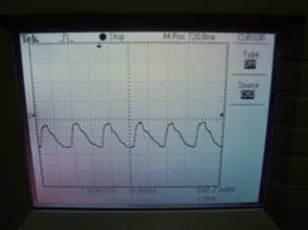

Figure 7.2.The output signal of the designed pulse oximeter system.

The designed medical telemetry system measures both the ECG signal and the level of saturated oxygen in the blood and then plots them together on a 128 x 64 pixel graphical LCD display (GLCD), as shown in Figure 7.3. The top waveform is the ECG, while the bottom waveform is the saturated oxygen level. The advantage of displaying both parameters on the same graph is that the doctor or the health specialist can quickly analyse the patient’s condition by looking at the graphs. The disadvantage of GLCD is its size that is very small, and the resolution is not enough for analysing ECG details by the doctor. For this reason, it is advisable to use large size GLCDs with high pixel rates.

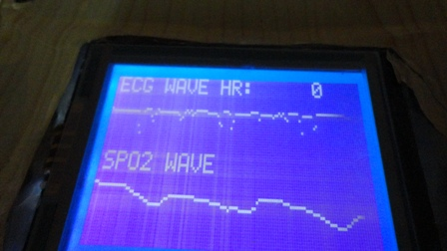

Figure 7.3.ECG and saturated oxygen signals plotted on a GLCD display.

The collected ECG and the saturated oxygen data are initially digitised by the microcontroller and stored on the local microcontroller memory. This data is then successfully sent to a remote location using the IPV4 protocols over a serial Ethernet link. A small serial Ethernet board was connected to the microcontroller output ports. The microcontroller was programmed to send the collected medical data via this serial Ethernet board to the health specialist that may be located at a remote location. Use of a serial Ethernet board simplified the overall design considerably and also reduces its cost.

The collected data is actually in HTML text format and thus it can be accessed by any mobile device (e.g. a mobile phone, an IPAD etc) that has connectivity to the internet. It should also be possible to send the data to a PC after some minor modifications so that the data can be analysed further and plotted in real-time if desired.

Some medical telemetry systems are based on the GPRS technology [4]. Such systems have limited data storage memories and distortion problems with very low speed and high cost compared to the system developed by the author.

In spite of these advantages, there are some disadvantages and limits of the system. Causing electromagnetic pollution of the system is inevitable. It is though that this electromagnetic distortion can be cause damage to environment. Effects of physical condition like as electric and electromagnetic fields, humidity, temperature to the electronic circuits of the system are the other limits of the system. Moreover, it is possible that Trojans, viruses and hackers can give the damage to software on microcontroller and receiver parts. For this reason, it might be necessary to take security precautions with software and extra equipments.

Because the designed medical telemetry system is low-cost and portable, further developments are possible. For example, all the system components can be placed on a small PCB and the system can be commercialised for use in homes, hospitals and in health clinics.

CHAPTER 8

CONCLUSIONS AND SUGGESTIONS FOR FUTURE WORK

Hospitals and other medical institutions employ medical telemetry devices to monitor patients’ vital signs and other important biological parameters and transmit this information via radio waves or wireless systems to a remote location, such as to doctors or nurses, or to other health specialists, using medical telemetry systems.

Medical telemetry systems continue to improve with the development of new communication technologies. In early days of medical telemetry, radio frequency waves have been used for communication, then internet technologies such as 3G and PDA have replaced the conventional medical telemetry systems.

The medical telemetry system designed and developed by the author is based on using the Ethernet to send the vital medical information of a patient to a remote doctor or a medical specialist. One of the benefits of the designed system is that it is low-cost and portable. As such, the system can be used at homes, especially in the care of elderly people who cannot go to hospitals easily.

The designed system senses and then transmits the ECG and SPO2 signals of the patient using the Ethernet technology. The system for example can be connected to an internet based mobile phone or to an IPAD and the data can easily be sent to the required place without the need of any other communication equipment. As the designed system is based on Ethernet protocols, any doctor or any specialist with a mobile phone can easily monitor a patient’s medical condition in real-time and at any place and at any time of the day.

The designed medical telemetry system can be developed further in several ways. One such development could be the design of a web based central monitoring system to keep track of the medical information from all patients registered to the system.

Another further development could be the interpretation of the results automatically and then sending alarm messages to doctors for emergency cases. For example, important anomalies (e.g. heart attack) can be detected in the ECG waveforms and this information can be sent as alarm condition to the doctors instead of sending the full ECG waveforms. The same alarm conditions can also be sent as urgent messages using the standard SMS messaging services. Such an addition to the system will make the system more responsive, especially when dealing emergency situations as this will give the opportunity to the doctor to visit the patient as early as possible.

The size of the designed electronic circuit can be minimized using nanotechnology components. It may then become possible to keep the system attached to the patient at all times. Wearable ECG and SPO2 sensors can be used with flexible connections to help the patient move freely. As the system is portable, it should then be possible to it not just at home but at any place and at any time.

Finally, the system can be further developed so that it can be controlled from a remote location using a suitable web service, e.g. email. In such an application the doctor may be required to request the data at any time by sending appropriate email or mobile phone messages to the system.

REFERENCES
[1] Güler N., Fidan U. (2005).Wireless Transmission of ECG Signal., Journal of Medical Systems., Volume 30, Number 3,231-235. DOI:10.1007/s10916-005-7980-5.
[2] Di G., Tang X., Liu W. (2007). A Reflectance Pulse Oximeter Design Using the MSP430F149. IEEE/ICME International Conference on Complex Medical Engineering. 1082-1084.
[3] Lee H., Park D. (2000). Bio-Medical FM-FM-FSK Radiotelemetry System for Multi-Signal Transmission, Proceedings of the 22nd Annual Conference, IEEE. 1053-1055.
[4] Boskovic A., Despotovic M.(2005). An Efficient Approach to ECG Signal Transmission via GPRS.,IEEE. 76-79. doi:1-4244-0049-X/05/$20.00
[5] Hong J., Kim J., Cha E., Lee T. (2007). A Wireless 3-Channel ECG Transmission System Using PDA Phone, IEEE Computer Society, 462-465. doi:10.1109/ICCIT.2007.318.
[6] Villegas G., Wong S., and students. A Portable ECG monitoring device with Bluetooth and Holter capabilities for Telemedicine Applications. Proceedings of the 28th IEEE EMBS Annual International Conference, 5244-5247.
[7] Rangraz P., Behnam H.(2008).Modelling Heart Wall Motion in Echocardiography System, 4th Kuala Lumpur International Conference on Biomedical Engineering., Volume 21/1 . 599-602.
[8]Coverings A. Structure of Heart. Retrieving from October 6, 2011, from http://media.wiley.com/product_data/excerpt/62/EHEP0018/EHEP001862.pdf
[9]Concept 3: Electrical activity of Hearth.(2011). Pearson Education., Retrieved from http://www.phschool.com/science/biology_place/biocoach/cardio1/electrical.htm
[10] Klabunde R.E. (2011). Cardiovascular Physiology Concepts., Second Edition., Lipincott Williams & Wilkins Press.
[11]Saunders W.B .(1979). Anaesthesia. Fifth Edition. Churchill Livingstone Press.
[12] Karilainen A., Hansen S., Müller J. (2005). Dry and Capacitive Electrodes for Long-Term ECG Monitoring., IEEE Transactions on Ultrasonics, Ferroelectrics and Frequency Control. Vol. 51. No. 11. Pp 154-161.
[13]Retrieved February 2, 2002 from http://www.madehow.com/Volume-3/ECG-Machine.html#ixzz0k8hEJ4y9
[14] Hampton J.R., The ECG in Practice.(2000)., Churchill Livingstone Press., Fourth Edition.
[15] O’Donnell M., Mich U., Webster. (2005). Biopotential Electrodes. Retrieved from Arizona State University Biomedical Engineering Lecture Notes Website: http://www.spx.arizona.edu/classes/bme517/lecture/_electrodes.pdf.
[16] Bronzino J.D., Medical Devices and Systems. (2006)., Third Edition., Taylor and Francis Group Press.

[17]Chew N., The History of Pulse Oximeter. Retrieved December 2, 2011, from http://www.ehow.com/about_5052102_history-pulse-oximetry.html.

[18]Barker S., Hay B., Miyasaka K., Poets C. (2000). Retrieved November 23, 2011, from http://www.oximetry.org/pulseox/principles.html.

[19]Li Y.T., Pulse Oximetry.(2001) , Department of Electronic Engineering.

[20]Townsend N., Medical Electronics Term 2001, Retrieved from Oxford University Robotic research group website : http://www.robots.ox.ac.uk/~neil/teaching/lectures/med_elec/notes6.pdf.
[21]Trump B., Stitt R., Sallen-Key Low Pass Filter Design Program, Burr-Brown Application Press, (602), 746-750.

APPENDIX A

INA128P Instrumentation Amplifier block diagram.
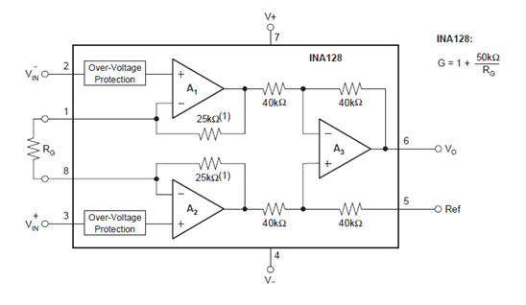

APPENDIX B
Nellcor Pulse Oximeter Pinout for disposable.
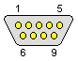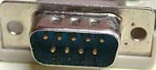

Connector End  Pin | Pin Name | Description
9 | Phototransistor Cathode | Green wire
5 | Phototransistor Anode | White wire; phototransistor detects level of IR and/or red light transmitted through the finger.
7 | Shield | Cable shield, connects the copper shield the over the transistor.
2 | LED1 | Red wire; anode of IR LED, cathode of the red LED
3 | LED2 | Black wire; cathode of IR LED, anode of the red LED

APPENDIX C
Program listing of designed Medical Telemetry System.
program calikusu
dim
SPI_Ethernet_Rst as sbit at LATG13_bit ' for writing to output pin always use latch
SPI_Ethernet_CS as sbit at LATG12_bit ' for writing to output pin always use latch
SPI_Ethernet_Rst_Direction as sbit at TRISG13_bit
SPI_Ethernet_CS_Direction as sbit at TRISG12_bit
' end ethernet NIC definitions
dim myMacAddr as byte[6] ' my MAC address
myIpAddr as byte[4] ' my IP address
gwIpAddr as byte[4] ' gateway (router) IP address
ipMask as byte[4] ' network mask (for example : 255.255.255.0)
dnsIpAddr as byte[4] ' DNS server IP address

'************************************************************
'* ROM constant strings
'************************************************************
const httpHeader as string[31] = "HTTP/1.1 200 OK"+chr(10)+"Content-type: " ' HTTP header
const httpMimeTypeHTML as string[13] = "text/html"+chr(10)+chr(10) ' HTML MIME type
const httpMimeTypeScript as string[14] = "text/plain"+chr(10)+chr(10) ' TEXT MIME type
const httpMethod as string[5] = "GET /"
'*
'* web page, splited into 2 parts as
'* when coming short of ROM, fragmented data is handled more efficiently by linker
'*
'* this HTML page calls the boards to get its status, and builds itself with javascript
'*

const indexPage as string[735] =
"<meta http-equiv=" + Chr(34) + "refresh" + Chr(34) + " content=" + Chr(34) + "3;url=http://192.168.20.60" + Chr(34) + ">" +
"<HTML><HEAD></HEAD><BODY>"+
"<h1>dsPIC + ENC28J60 Mini Web Server</h1>"+
"<a href=/>Reload</a>"+
"<script src=/s></script>"+
"<table><tr><td valign=top><table border=1 style="+chr(34)+"font-size:20px ;font-family: terminal ;"+chr(34)+"> "+
"<tr><th colspan=2>ADC</th></tr>"+
"<tr><td>AN10</td><td><script>document.write(AN10)</script></td></tr>"+
"</table></td><td><table border=1 style="+chr(34)+"font-size:20px ;font-family: terminal ;"+chr(34)+"> "+
"<tr><th colspan=2>PORTB</th></tr>"+
"<script>"+
"var str,i;"+
"str="+chr(34)+chr(34)+"; "+
"for(i=0;i<8;i++)"+
"{str+="+chr(34)+"<tr><td bgcolor=pink>BUTTON #"+chr(34)+"+i+"+chr(34)+"</td>"+chr(34)+"; "+
"if(PORTB&(1<<i)){str+="+chr(34)+"<td bgcolor=red>ON"+chr(34)+";}"+
"else {str+="+chr(34)+"<td bgcolor=#cccccc>OFF"+chr(34)+";}"+
"str+="+chr(34)+"</td></tr>"+chr(34)+";}"+
"document.write(str) ;"+
"</script>"

const indexPage2 as string[470] =
"</table></td><td>"+
"<table border=1 style="+chr(34)+"font-size:20px ;font-family: terminal ;"+chr(34)+"> "+
"<tr><th colspan=3>PORTD</th></tr>"+
"<script>"+
"var str,i;"+
"str="+chr(34)+chr(34)+"; "+
"for(i=0;i<8;i++)"+
"{str+="+chr(34)+"<tr><td bgcolor=yellow>LED #"+chr(34)+"+i+"+chr(34)+"</td>"+chr(34)+"; "+
"if(PORTD&(1<<i)){str+="+chr(34)+"<td bgcolor=red>ON"+chr(34)+";}"+
"else {str+="+chr(34)+"<td bgcolor=#cccccc>OFF"+chr(34)+";}"+
"str+="+chr(34)+"</td><td><a href=/t"+chr(34)+"+i+"+chr(34)+">Toggle</a></td></tr>"+chr(34)+";}"+
"document.write(str) ;"+
"</script>"+
"</table></td></tr></table>"+
"This is HTTP request #<script>document.write(REQ)</script></BODY></HTML>"

dim getRequest as byte[15] ' HTTP request buffer
dyna as char[30] ' buffer for dynamic response
httpCounter as word ' counter of HTTP requests
txt as string[11]

'*******************************************
'* user defined functions
'*******************************************

'*
'* this function is called by the library
'* the user accesses to the HTTP request by successive calls to SPI_Ethernet_getByte()
'* the user puts data in the transmit buffer by successive calls to SPI_Ethernet_putByte()
'* the function must return the length in bytes of the HTTP reply, or 0 if nothing to transmit
'*
'* if you don"t need to reply to HTTP requests,
'* just define this function with a return(0) as single statement
'*
'*
sub function SPI_Ethernet_UserTCP(dim byref remoteHost as byte[4],
dim remotePort, localPort, reqLength as word, dim byref flags as TEthPktFlags) as word
dim i as word ' my reply length
bitMask as byte ' for bit mask
txt as string[11]
result = 0

' should we close tcp socket after response is sent?
' library closes tcp socket by default if canClose flag is not reset here
' canClose = 0 ' 0 - do not close socket
' otherwise - close socket

if(localPort <> 80) then ' I listen only to web request on port 80
result = 0
exit
end if

' get 10 first bytes only of the request, the rest does not matter here
for i = 0 to 10
getRequest[i] = SPI_Ethernet_getByte()
next i

getRequest[i] = 0

' copy httpMethod to ram for use in memcmp routine
for i = 0 to 4
txt[i] = httpMethod[i]
next i

if(memcmp(@getRequest, @txt, 5) <> 0) then ' only GET method is supported here
result = 0
exit
end if

Inc(httpCounter) ' one more request done

if(getRequest[5] = "s") then ' if request path name starts with s, store dynamic data in transmit buffer
' the text string replied by this request can be interpreted as javascript statements
' by browsers

result = SPI_Ethernet_putConstString(@httpHeader) ' HTTP header
result = result + SPI_Ethernet_putConstString(@httpMimeTypeScript) ' with text MIME type

' add AN10 value to reply
WordToStr(ADC1_Get_Sample(10), dyna)
txt = "var AN10="
result = result + SPI_Ethernet_putString(@txt)
result = result + SPI_Ethernet_putString(@dyna)
txt = ";"
result = result + SPI_Ethernet_putString(@txt)

' add PORTB value (buttons) to reply
txt = "var PORTB="
result = result + SPI_Ethernet_putString(@txt)
WordToStr(PORTB, dyna)
result = result + SPI_Ethernet_putString(@dyna)
txt = ";"
result = result + SPI_Ethernet_putString(@txt)

' add PORTD value (LEDs) to reply
txt = "var PORTD="
result = result + SPI_Ethernet_putString(@txt)
WordToStr(PORTD, dyna)
result = result + SPI_Ethernet_putString(@dyna)
txt = ";"
result = result + SPI_Ethernet_putString(@txt)

' add HTTP requests counter to reply
WordToStr(httpCounter, dyna)
txt = "var REQ="
result = result + SPI_Ethernet_putString(@txt)
result = result + SPI_Ethernet_putString(@dyna)
txt = ";"
result = result + SPI_Ethernet_putString(@txt)
else
if(getRequest[5] = "t") then ' if request path name starts with t, toggle PORTD (LED) bit number that comes after
bitMask = 0
if(isdigit(getRequest[6]) <> 0) then ' if 0 <= bit number <= 9, bits 8 & 9 does not exist but does not matter
bitMask = getRequest[6] - "0" ' convert ASCII to integer
bitMask = 1 << bitMask ' create bit mask
PORTD = PORTD xor bitMask ' toggle PORTD with xor operator
end if
end if
end if

if(result = 0) then ' what do to by default
result = SPI_Ethernet_putConstString(@httpHeader) ' HTTP header
result = result + SPI_Ethernet_putConstString(@httpMimeTypeHTML) ' with HTML MIME type
result = result + SPI_Ethernet_putConstString(@indexPage) ' HTML page first part
result = result + SPI_Ethernet_putConstString(@indexPage2) ' HTML page second part
end if

' return to the library with the number of bytes to transmit
end sub

' *
' * this function is called by the library
' * the user accesses to the UDP request by successive calls to Ethernet_getByte()
' * the user puts data in the transmit buffer by successive calls to Ethernet_putByte()
' * the function must return the length in bytes of the UDP reply, or 0 if nothing to transmit
' *
' * if you don't need to reply to UDP requests,
' * just define this function with a return(0) as single statement
' *
' *
sub function SPI_Ethernet_UserUDP(dim byref remoteHost as byte[4],
dim remotePort, destPort, reqLength as word, dim byref flags as TEthPktFlags) as word
dim txt as string[5]
result = 0
' reply is made of the remote host IP address in human readable format
byteToStr(remoteHost[0], dyna) ' first IP address byte
dyna[3] = "."
byteToStr(remoteHost[1], txt) ' second
dyna[4] = txt[0]
dyna[5] = txt[1]
dyna[6] = txt[2]
dyna[7] = "."
byteToStr(remoteHost[2], txt) ' second
dyna[8] = txt[0]
dyna[9] = txt[1]
dyna[10] = txt[2]

dyna[11] = "."
byteToStr(remoteHost[3], txt) ' second
dyna[12] = txt[0]
dyna[13] = txt[1]
dyna[14] = txt[2]

dyna[15] = ":" ' add separator

' then remote host port number
WordToStr(remotePort, txt)
dyna[16] = txt[0]
dyna[17] = txt[1]
dyna[18] = txt[2]
dyna[19] = txt[3]
dyna[20] = txt[4]
dyna[21] = "["
WordToStr(destPort, txt)
dyna[22] = txt[0]
dyna[23] = txt[1]
dyna[24] = txt[2]
dyna[25] = txt[3]
dyna[26] = txt[4]
dyna[27] = "]"
dyna[28] = 0

' the total length of the request is the length of the dynamic string plus the text of the request
result = 28 + reqLength

' puts the dynamic string into the transmit buffer
SPI_Ethernet_putBytes(@dyna, 28)

' then puts the request string converted into upper char into the transmit buffer
while(reqLength <> 0)
SPI_Ethernet_putByte(SPI_Ethernet_getByte())
Dec(reqLength)
wend

' back to the library with the length of the UDP reply
end sub

' Glcd module connections
dim GLCD_D7 as sbit at RD7_bit
GLCD_D6 as sbit at RD6_bit
GLCD_D5 as sbit at RD5_bit
GLCD_D4 as sbit at RD4_bit
GLCD_D3 as sbit at RD3_bit
GLCD_D2 as sbit at RD2_bit
GLCD_D1 as sbit at RD1_bit
GLCD_D0 as sbit at RD0_bit
GLCD_D7_Direction as sbit at TRISD7_bit
GLCD_D6_Direction as sbit at TRISD6_bit
GLCD_D5_Direction as sbit at TRISD5_bit
GLCD_D4_Direction as sbit at TRISD4_bit
GLCD_D3_Direction as sbit at TRISD3_bit
GLCD_D2_Direction as sbit at TRISD2_bit
GLCD_D1_Direction as sbit at TRISD1_bit
GLCD_D0_Direction as sbit at TRISD0_bit

dim GLCD_CS1 as sbit at LATB3_bit
GLCD_CS2 as sbit at LATB2_bit
GLCD_RS as sbit at LATB4_bit
GLCD_RW as sbit at LATB5_bit
GLCD_EN as sbit at LATB6_bit
GLCD_RST as sbit at LATB7_bit
GLCD_CS1_Direction as sbit at TRISB3_bit
GLCD_CS2_Direction as sbit at TRISB2_bit
GLCD_RS_Direction as sbit at TRISB4_bit
GLCD_RW_Direction as sbit at TRISB5_bit
GLCD_EN_Direction as sbit at TRISB6_bit
GLCD_RST_Direction as sbit at TRISB7_bit
' End Glcd module connections

dim ADCresult as word
ADCresult1 as word
casi as word

dim i,son as integer

dim invert as word
dim x1, x2,x3 as integer
dim Y1, Y2, Y3,cnt as integer
dim counter,HR as word
dim cali as byte
dim text as string[6]
main:

httpCounter = 0
myMacAddr[0] = 0x00
myMacAddr[1] = 0x14
myMacAddr[2] = 0xA5
myMacAddr[3] = 0x76
myMacAddr[4] = 0x19
myMacAddr[5] = 0x3F

' set IP address
myIpAddr[0] = 192
myIpAddr[1] = 168
myIpAddr[2] = 20
myIpAddr[3] = 60

' set gateway address
gwIpAddr[0] = 192
gwIpAddr[1] = 168
gwIpAddr[2] = 20
gwIpAddr[3] = 6

' set dns address
dnsIpAddr[0] = 192
dnsIpAddr[1] = 168
dnsIpAddr[2] = 20
dnsIpAddr[3] = 1

' set subnet mask
ipMask[0] = 255
ipMask[1] = 255
ipMask[2] = 255
ipMask[3] = 0

ADPCFG = ADPCFG or 0xFBFF ' all digital but rb10(AN10)

PORTB = 0
TRISB = 0xFFFF ' set PORTB as input for buttons and adc

PORTD = 0
TRISD = 0 ' set PORTD as output,
' Configure AN pins as digital
Glcd_Init()
Glcd_Fill(0x00)
TRISB.13=1
TRISB.10=1
TRISB.1=1
counter=0
X2 = 0
X3= 0
for i=0 to 10
Glcd_Fill(0x00)
Glcd_Write_Text("ISMAILCALIKUSU", 1, 1, 2)
Delay_ms(100)
Glcd_Write_Text("MASTER THESIS",1,3,2)
Delay_ms(100)
Glcd_Write_Text("BIOMEDICAL",2,5,2)
Delay_ms(100)
Glcd_Write_Text("ENGINEERING",2,7,2)
Delay_ms(1000)
next i
Glcd_Fill(0x00)
ADC1_Init()

'*
'* starts ENC28J60 with as
'* reset bit on RC0
'* CS bit on RC1
'* my MAC & IP address
'* full duplex
'*
'SPI2_Init()
' for faster SPI communication use Spi2_Init_Advanced settings
Spi2_Init_Advanced(_SPI_MASTER, _SPI_8_BIT, _SPI_PRESCALE_SEC_1, _SPI_PRESCALE_PRI_4,
_SPI_SS_DISABLE, _SPI_DATA_SAMPLE_MIDDLE, _SPI_CLK_IDLE_LOW, _SPI_IDLE_2_ACTIVE)
SPI_Ethernet_Init(myMacAddr, myIpAddr, _SPI_Ethernet_FULLDUPLEX) ' init ethernet module
SPI_Ethernet_setUserHandlers(@SPI_Ethernet_UserTCP, @SPI_Ethernet_UserUDP)' set user handlers

' dhcp will not be used here, so use preconfigured addresses
SPI_Ethernet_confNetwork(ipMask, gwIpAddr, dnsIpAddr)
HR=0
counter=0

while TRUE ' do forever
SPI_Ethernet_doPacket() ' process incoming Ethernet packets

ADCresult1=ADC1_Read(14)
ADCresult= ADC1_Read(10)
Y3=ADCresult1 *64/4096
Y2 = ADCresult * 64 /4096
Y3=not Y3
Y2=not Y2
IntToStr(HR, text)
Glcd_Write_Text("ECG WAVE HR:"+text,2,0,1)
Glcd_Write_Text("SPO2 WAVE ",2,4,1)

Glcd_Dot(x3,y3+28,1)
Glcd_Dot(x2,y2+58,1)
delay_us(500)
inc(x2)
inc(x3)
if x3>127 then
x3=0
Glcd_Fill(0x00)
end if
x1=x2
if x2 > 127 then
x2 = 0
Glcd_Fill(0x00)
end if

if counter>=20 then
HR=60000/counter
end if
wend
end.
APPENDIX D
Pulse Oximeter Signal often eliminating the noise and DC offset.

